PROJECT REPORT

(Session 2022-2023)

**SPORTIFY**

**(E-Commerce Website)**



**Submitted to :** **Submitted by:**

Md. Farmanul Haque Vivek Kumar(201500805)

Ritik Kaushik(201500675)

Piyush Singh (201500472)

Shivani Singh (201500660)

Smriti Gangwar (201500694)

**Declaration**

We hereby declare that the work which is being presented in the Sportify(e-commerce website) , is in partial fulfilment of the requirements for an authentic record of our work under the supervision of Md. Farmanul Haque.

Vivek Kumar(201500805)

Ritik Kaushik(201500675)

Piyush Singh (201500472)

Shivani Singh (201500660)

Smriti Gangwar (201500694)

**Certificate**

This is to certify that the mini-project work entitled " Sportify " is a bonafide work carried out by Vivek Kumar(201500805), Ritik Kaushik(201500574), Piyush Singh(201500472), Shivani Singh(201500660), Smriti Gangwar(201500694) is in partial fullfilment of the requirements under our guidance and supervision.

Md. Farmanul Haque

Mentor

**Acknowledgement**

It gives me a great sense of pleasure to present the report of the Sportify e-commerce website under mini project during B. Tech. Third Year.

This project in itself is an acknowledgement to the inspiration, drive and technical assistance contributed to it by many individuals. This project would never have seen the light of the day without the help and

guidance that I have received.

My heartiest thanks to Dr. (Prof). Anand Singh Jalal, Head of Dept.,

Department of CEA for providing me with an encouraging platform to

develop this project, which thus helped me in shaping my abilities

towards a constructive goal.

The sincerity, thoroughness and perseverance have been a constant

source of inspiration for me. He has showered me with all his

extensively experienced ideas and insightful comments at virtually all

stages of the project & has also taught me about the latest industry-

oriented technologies.

I also do not like to miss the opportunity to acknowledge the

contribution of all faculty members of the department for their kind

guidance and cooperation during the development of my project. Last

but not the least, I acknowledge my friends for their contribution in the

completion of the project.

Index

1. Introduction
2. Content
3. Code
4. Conclusion
5. Reference

## Introduction

In today’s digital era, no matter what your area of business is, a strong online presence can be your most important selling point. And when the industry is all about visual appeal, an online presence becomes even more important to convey your design style and get in new clients.

* Interior designing is one such field filled with portfolio folders and samples. Interior design websites have become the driving force to reach out to a wider audience and create intrigue and higher visibility. An attractive visual presentation of your vision is another advantage of having an interior design website.

## 

## 

## **Content**

## Project Details:-

* + Project Name:-Sportify
  + Language Used:- HTML,CSS,JS
  + User Interface Designs:-HTML ,CSS , Bootstrap
  + Web Browser:-Chrome
  + Tool Used:-VS Code,Github
  + Server:-Localhost and Live server of VS

## 

## THE WEBSITE

* + - The website include homes, product and furniture design, wall colors, technology, house plans to the future of design. The website **documents inspiration to provide readers with the best home interior images online**.
    - The website is developed using HTML, CSS, JavaScript.

HOME PAGE

The first impression is the last. This line should be the foundation of your homepage. Home page is the first thing customers see when they land on your website, and you don’t want to go wrong with that. This is the place to capture their attention, and they decide if they wish to delve into the other pages.

A homepage should be rife with details yet simple. Color schemes, images, font, tone—every element affects the customer’s subconscious thinking. The page should be clutter-free, inviting, and pleasing to the eyes.

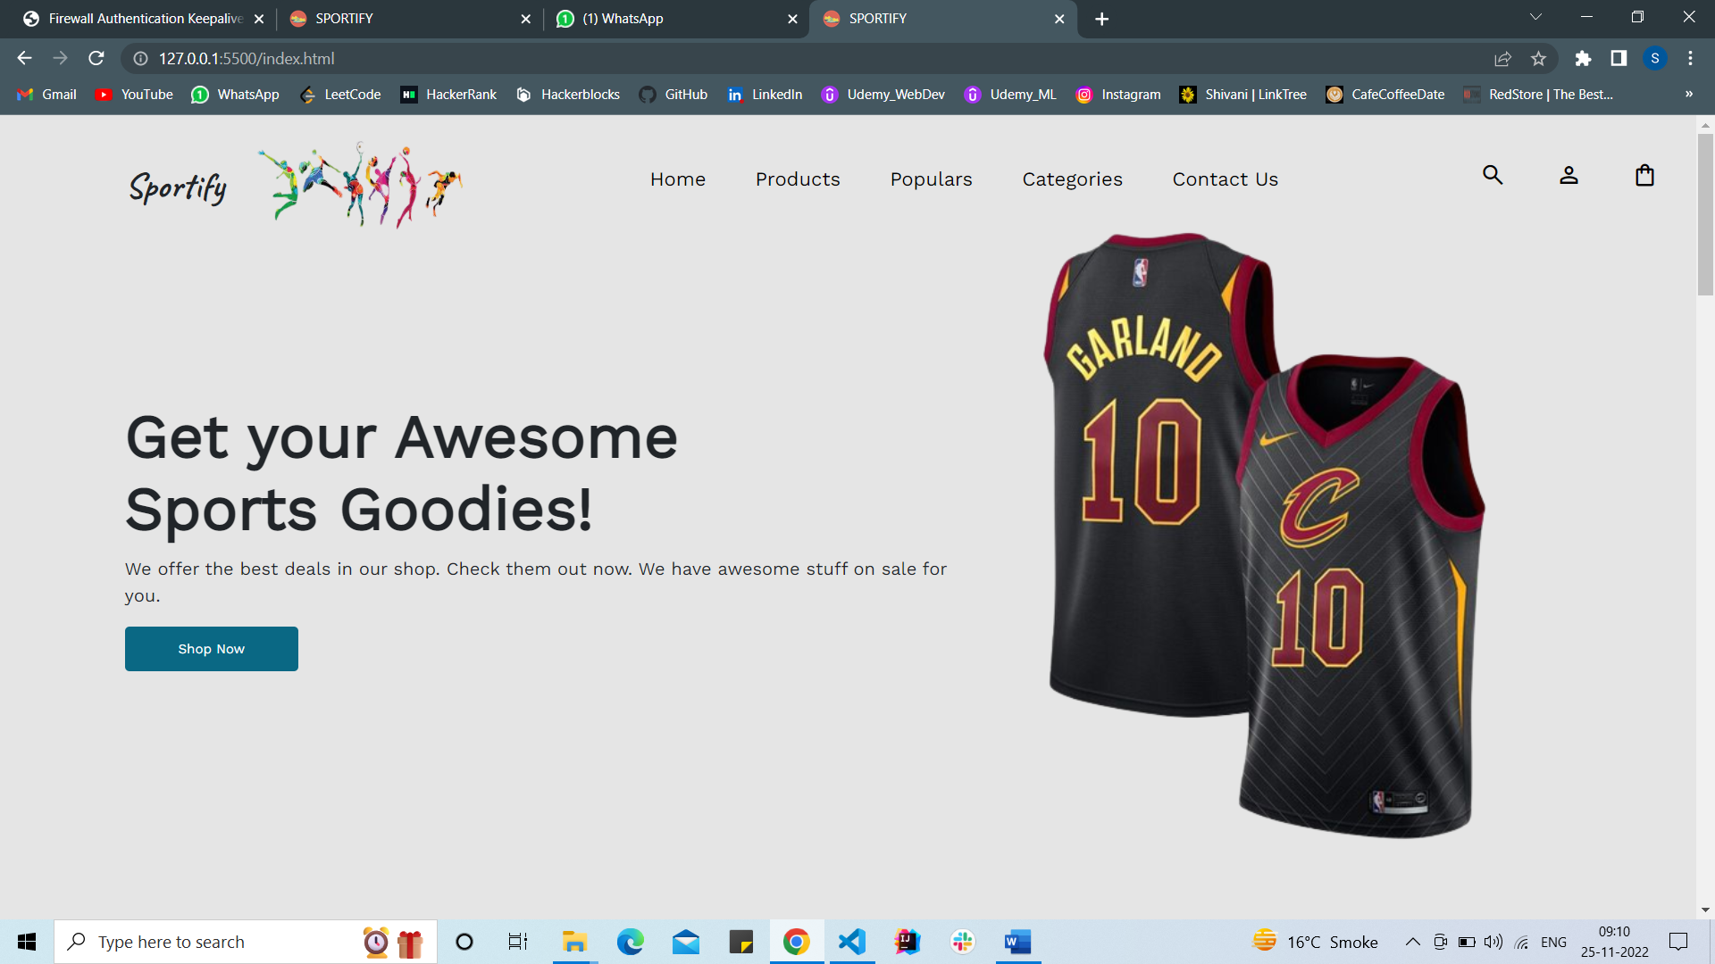

SIGN-UP PAGE

* The sign-up page has features like full name, email , username, password.
* The user can create an account by giving their full name, email id , username, password.
* Once the Signup button is clicked, the user credentials will get stored.

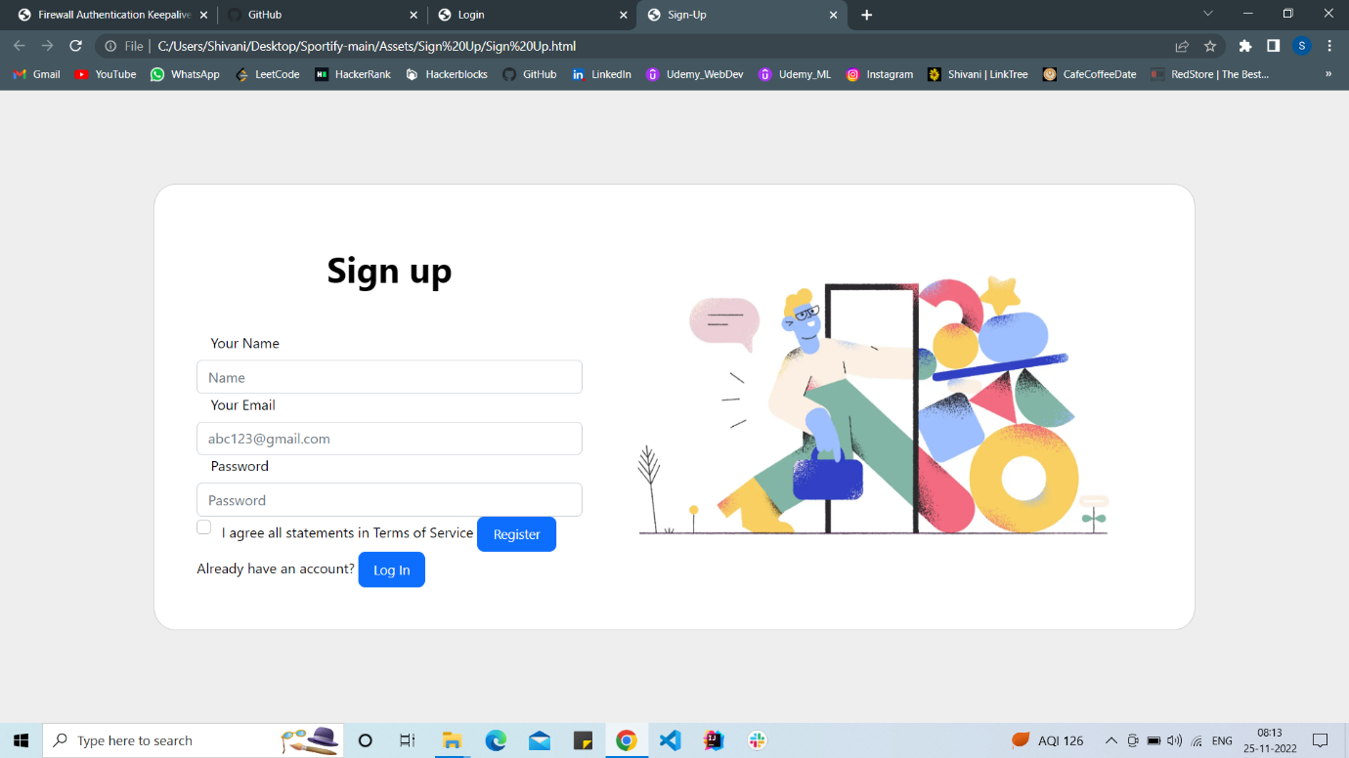

LOGIN PAGE

* In this page, the user can login to the website using their respective username and password.
* On clicking the login, the application will authenticate the user with the credentials stored

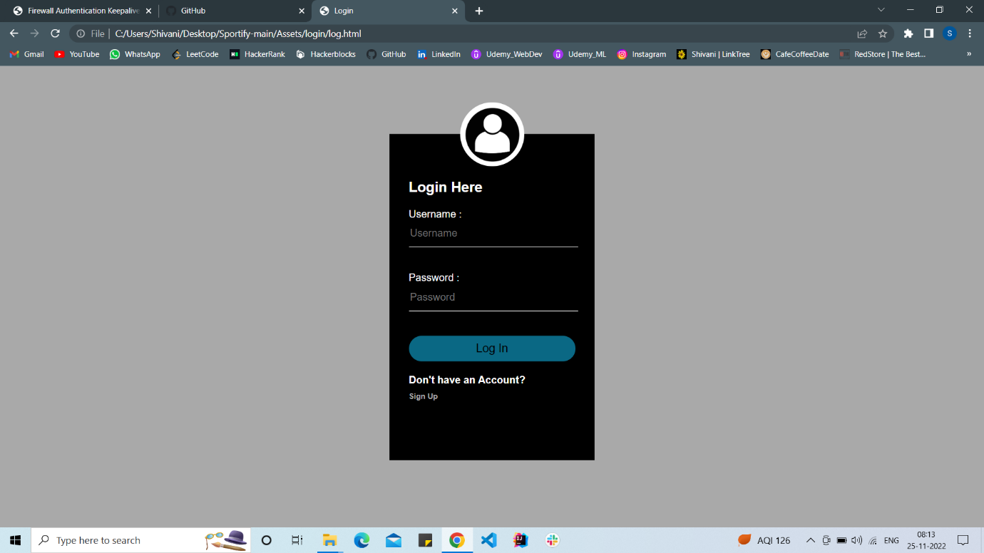

FEATURED

“Cricket Helmet, Shuttle Cock, Hockey Stick, Tennis Balls, and many more”

This page hosts galleries of all the sports goodies in a wide range of styles.

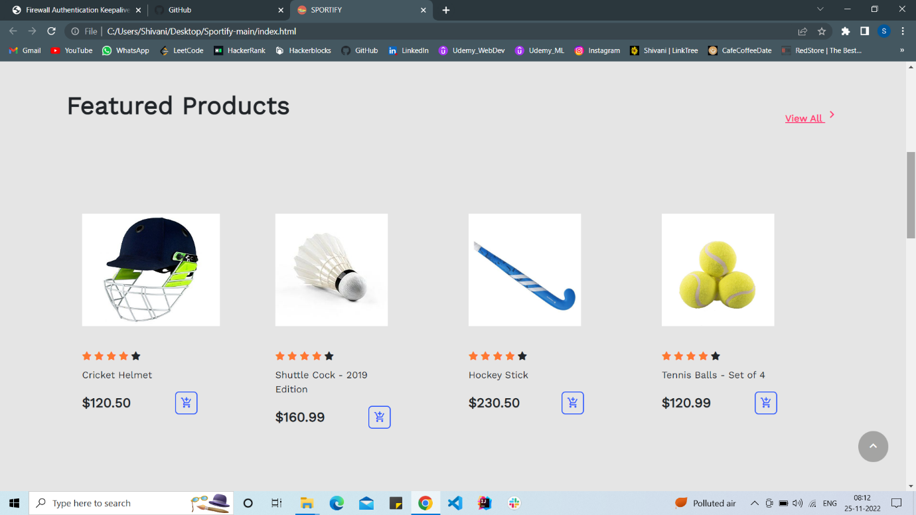

POPULARS

* This page showcases the product that have been in demand in past week.
* The user will know the trendiest style by looking at this page which will gain their interest and they can order the product with just single tap.

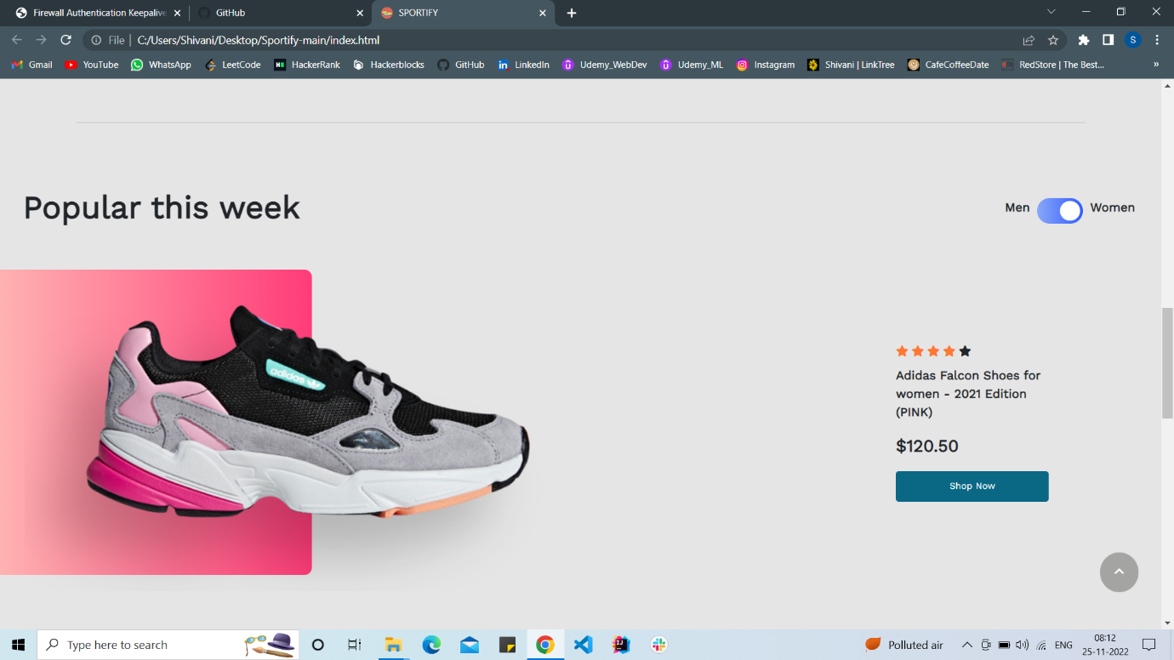

CATEGORIES

* This page showcases the different range of categories that we provide like men , kids and women collection.
* The user can select the category upon their interest and we provide the products that we showcase, The user have plenty of options to look stylish while playing sports which will give them a confidence boost which we all need in today’s era.
* Men’s Collection:

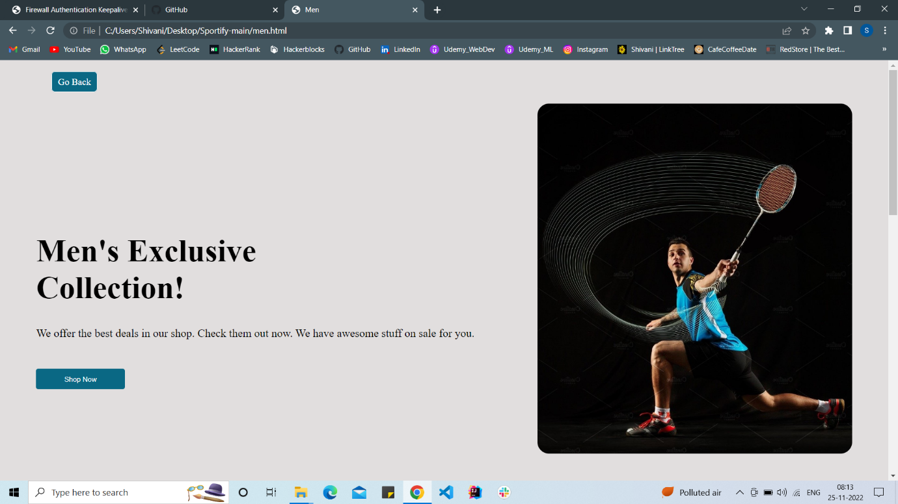

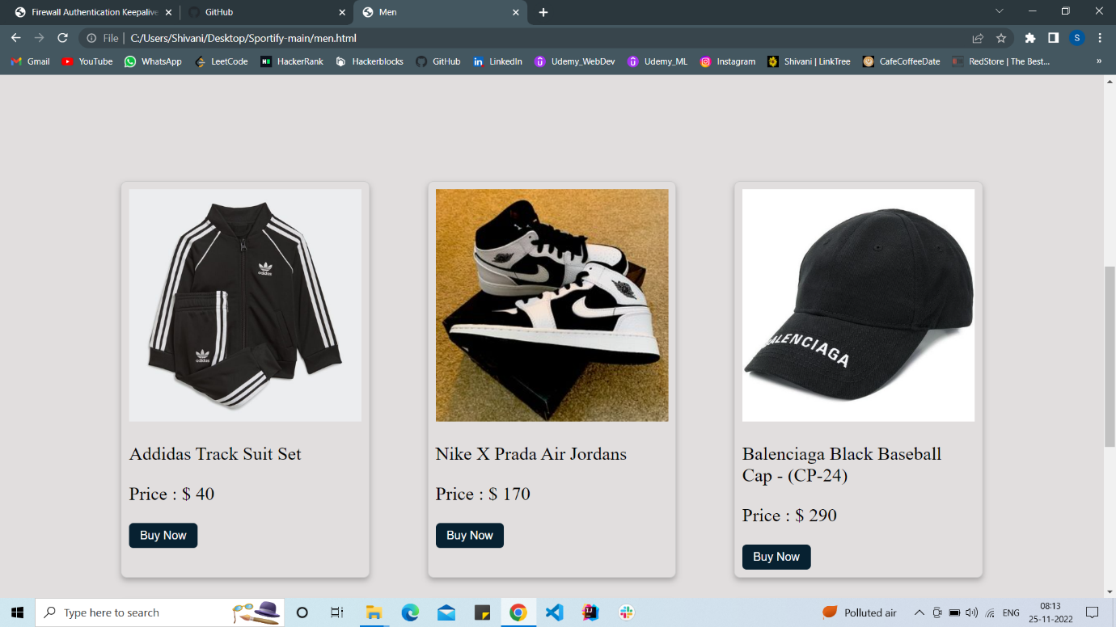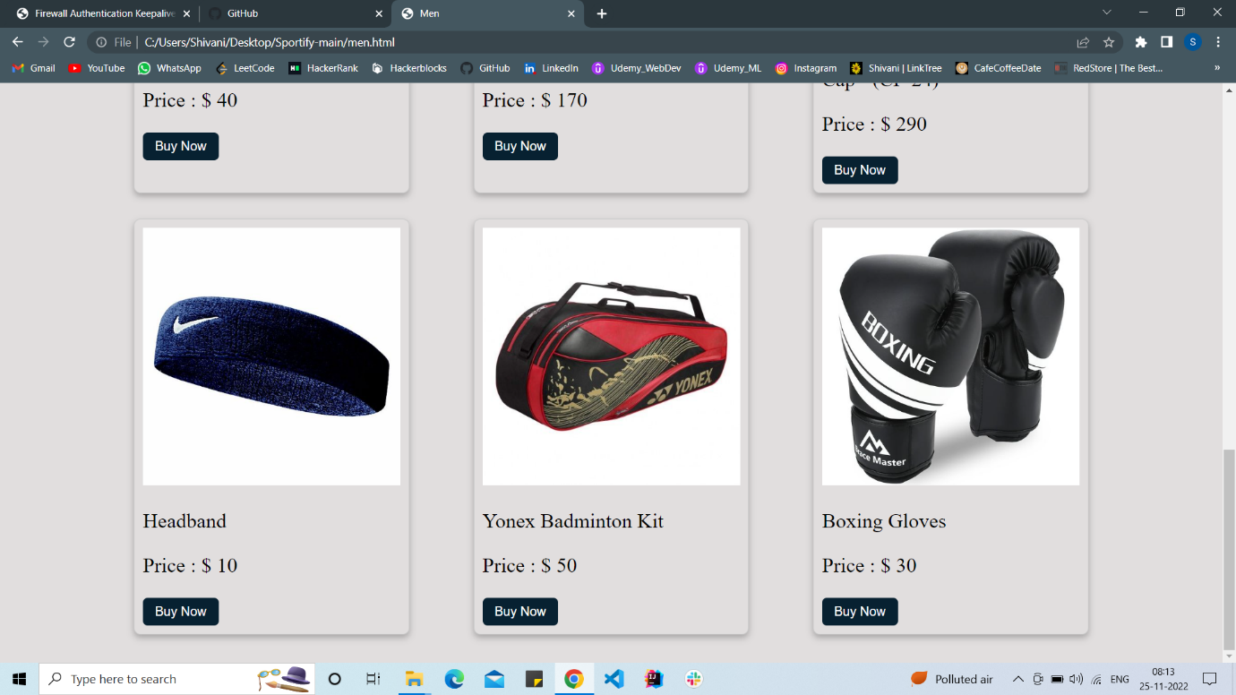

* Kid’s Collection:

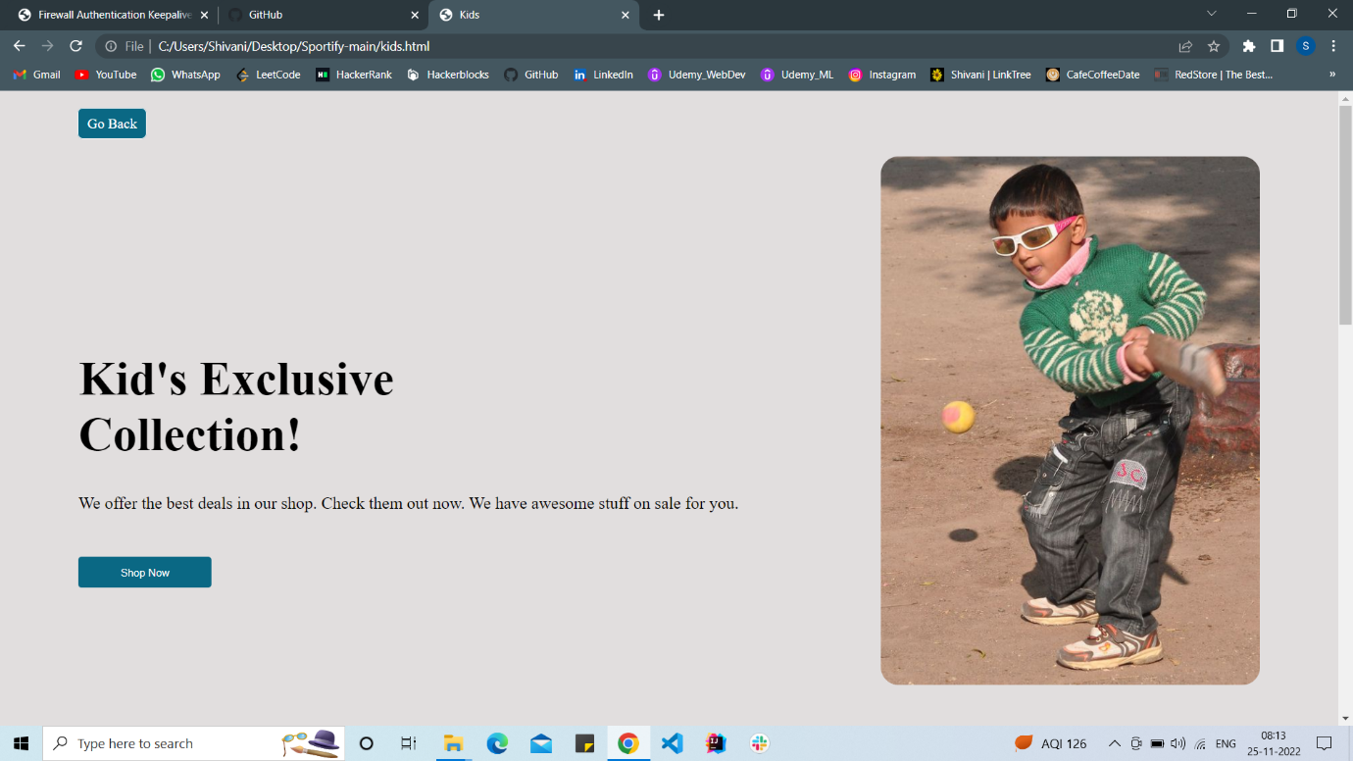

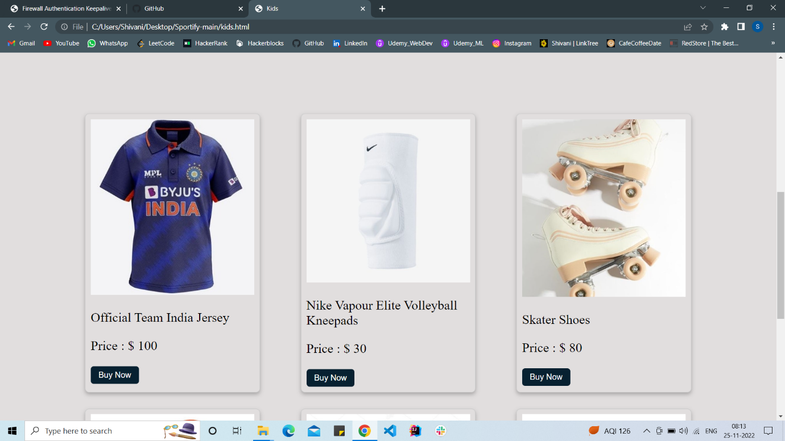

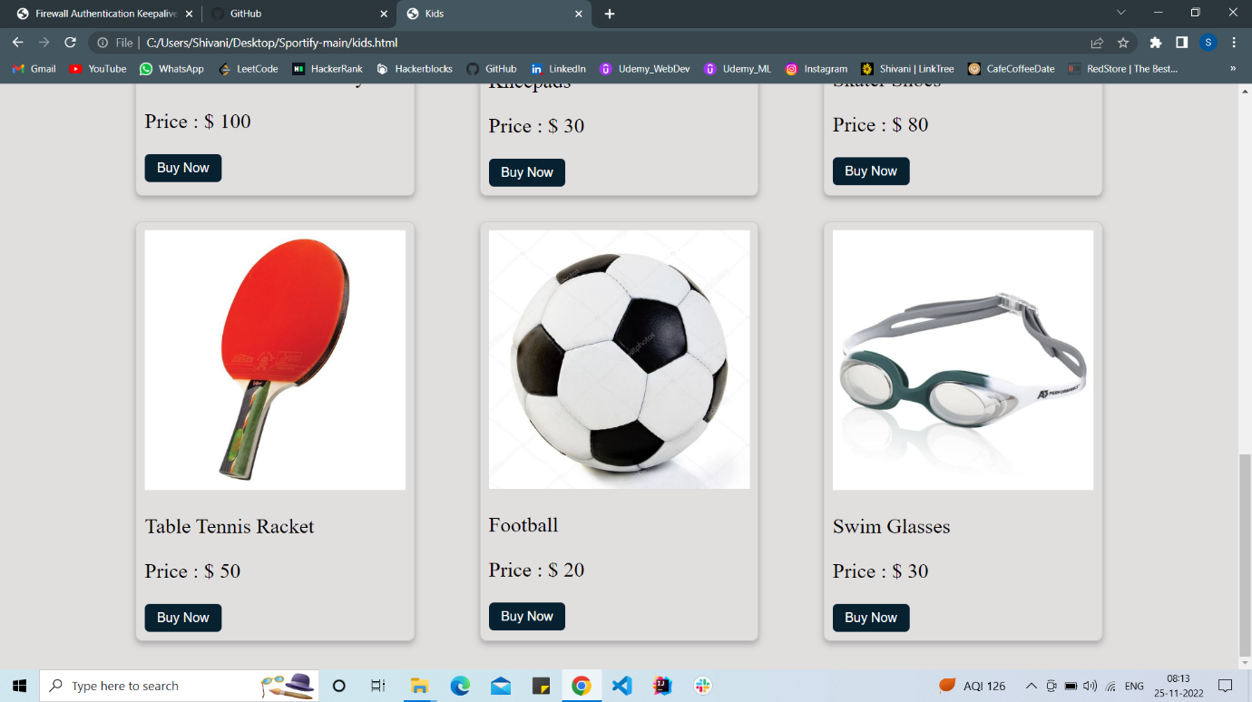

* 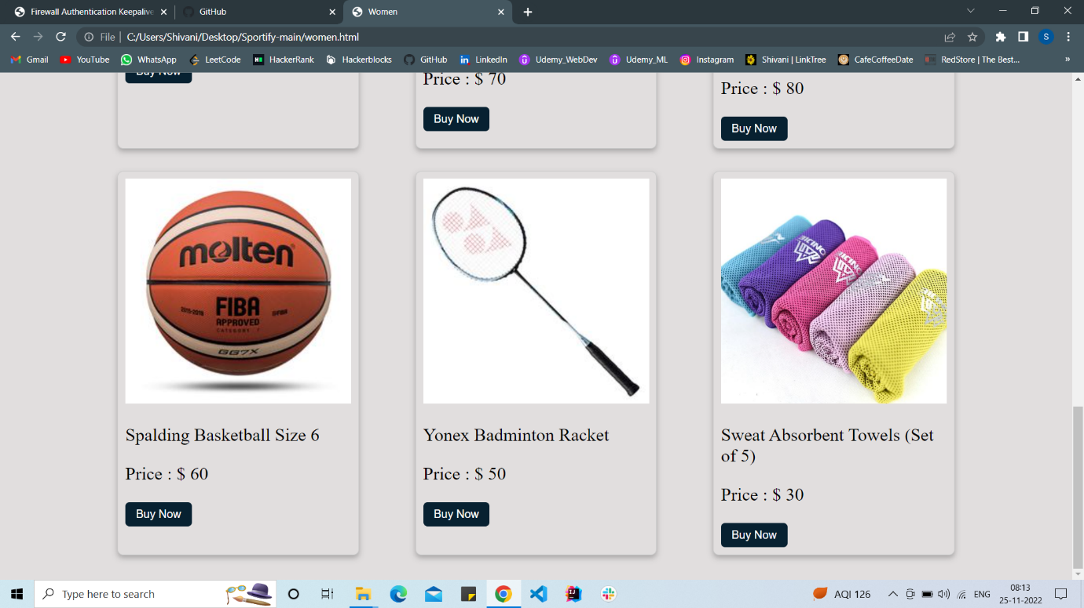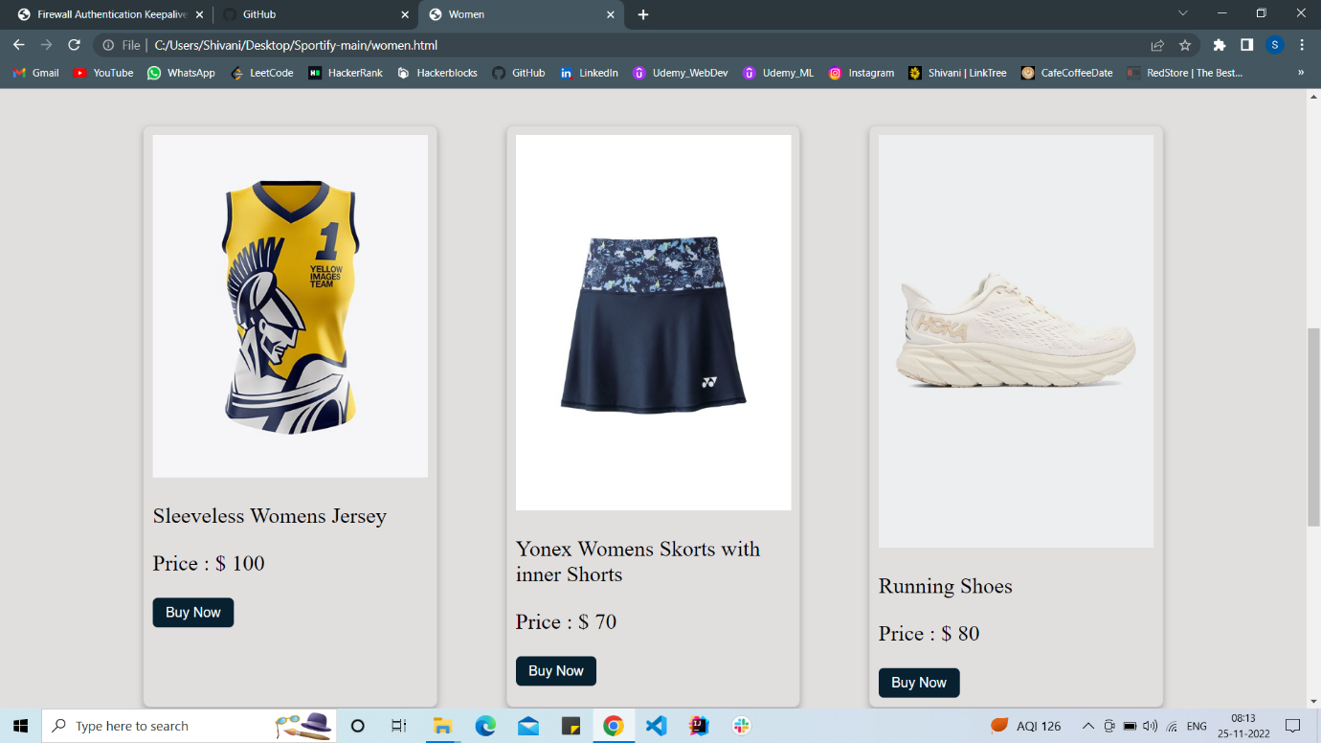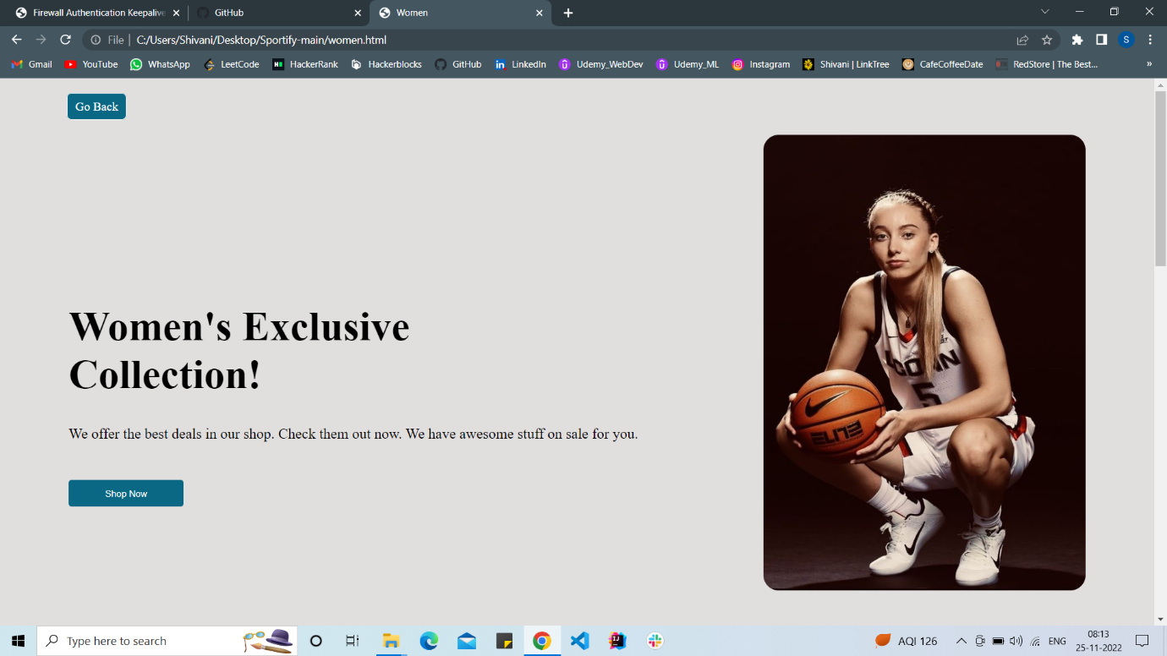Women’s Collection:

SHOPPING CART

* The shopping cart is added so that user can add their products that they want to buy in single click.
* The shopping cart has features to add or remove the item from the cart or to clear the cart.
* A message is displayed when we add any item to the cart.
* A successful transaction from the cart displays a check sign indicating that the order has been placed successfully.

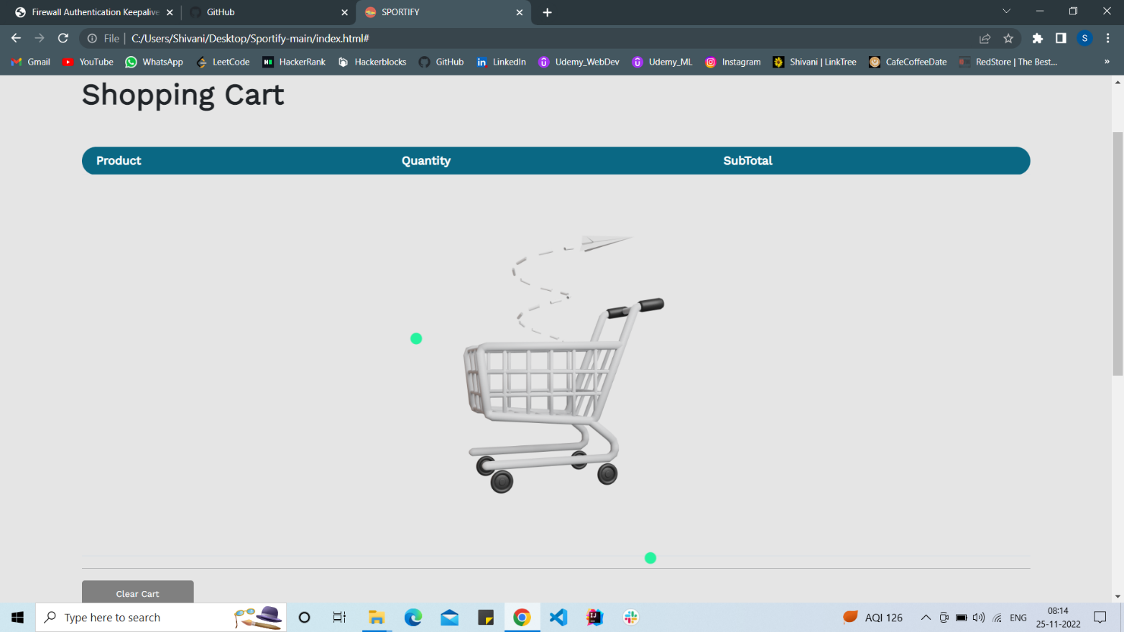

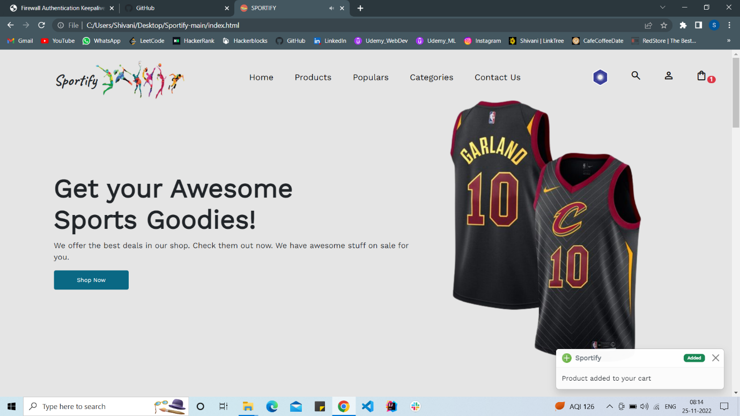

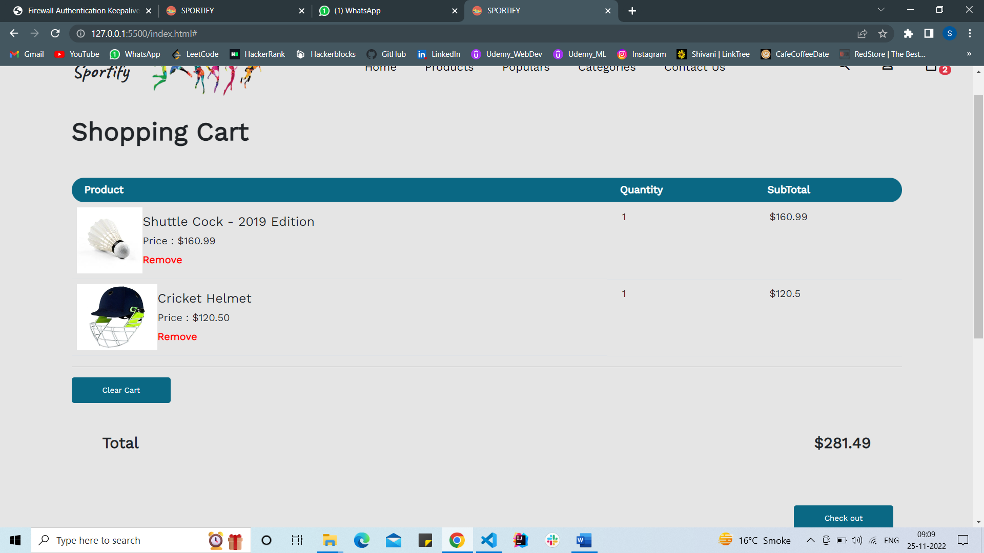

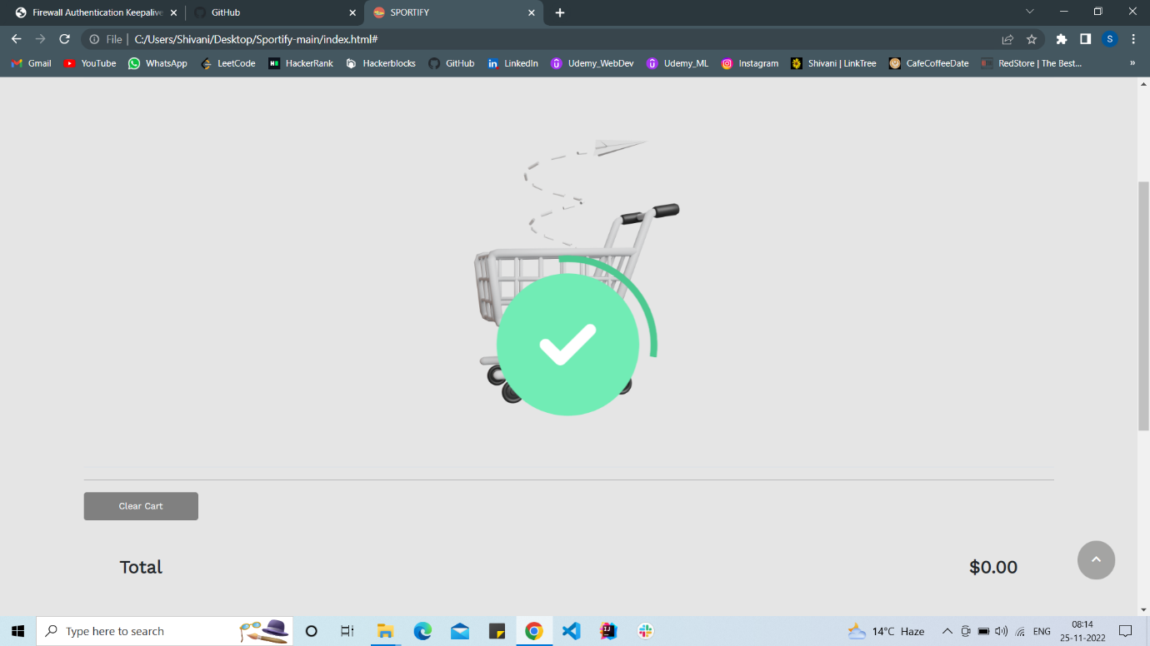

CONTACT PAGE

* The user can contact the author of the website using this contact form.
* The user can enter his Name, email address along with the body of message.
* After entering the data in the contact form, when the user click the submit button, the email will be sent to the author.

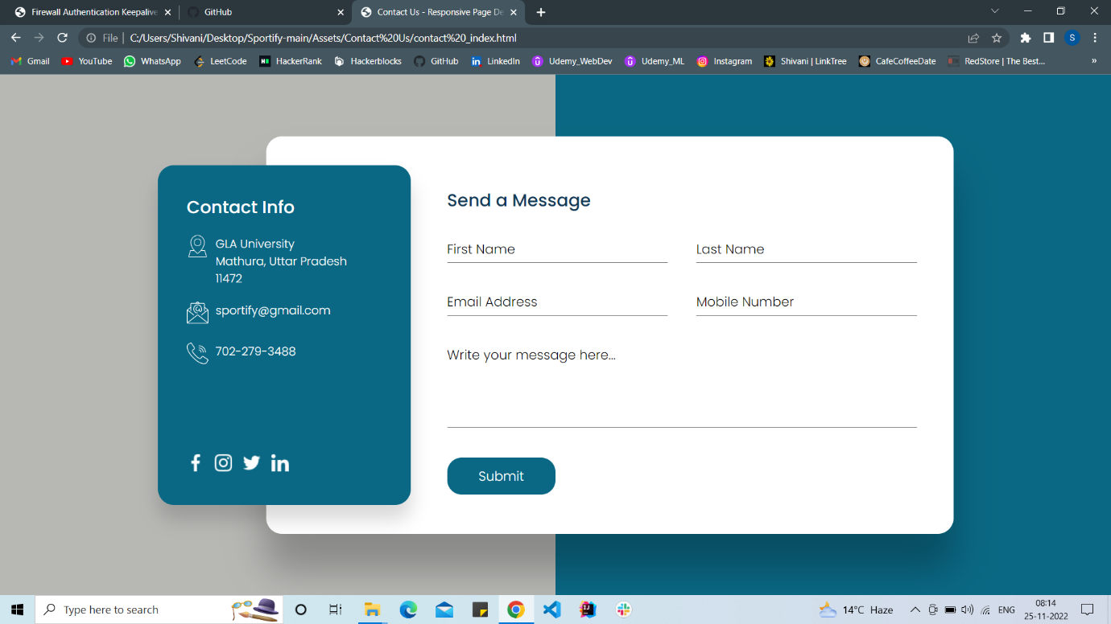

CODE

* index.html

<!DOCTYPE html>

<html lang="en">

<head>

    <meta charset="UTF-8">

    <meta http-equiv="X-UA-Compatible" content="IE=edge">

    <meta name="viewport" content="width=device-width, initial-scale=1.0">

    <title>SPORTIFY</title>

*<!-- favicon -->*

    <link rel="icon" type="image/x-icon" href="./Assets/img/favicon.ico">

*<!-- stylesheet -->*

    <link rel="stylesheet" href="./Assets/css/style.css">

    <link rel="stylesheet" href="./Assets/css/phone.css">

*<!-- fonts -->*

    <link rel="preconnect" href="https://fonts.googleapis.com">

    <link rel="preconnect" href="https://fonts.gstatic.com" crossorigin>

    <link href="https://fonts.googleapis.com/css2?family=Work+Sans&display=swap" rel="stylesheet">

*<!-- icons  -->*

    <link rel="stylesheet" href="https://cdnjs.cloudflare.com/ajax/libs/font-awesome/4.7.0/css/font-awesome.min.css">

    <script src="https://kit.fontawesome.com/2c36e9b7b1.js" crossorigin="anonymous"></script>

    <link rel="stylesheet"

        href="https://fonts.googleapis.com/css2?family=Material+Symbols+Outlined:opsz,wght,FILL,GRAD@20..48,100..700,0..1,-50..200" />

*<!-- bootstrap -->*

    <link href="https://cdn.jsdelivr.net/npm/bootstrap@5.2.2/dist/css/bootstrap.min.css" rel="stylesheet"

        integrity="sha384-Zenh87qX5JnK2Jl0vWa8Ck2rdkQ2Bzep5IDxbcnCeuOxjzrPF/et3URy9Bv1WTRi" crossorigin="anonymous">

    <audio id="myAudio">

        <source src="./Assets/js/click.mp3" type="audio/mp3">

    </audio>

</head>

<body onload="Loader()">

    <div id="main">

        <lottie-player id="lottie" class="lottie" src="https://assets3.lottiefiles.com/packages/lf20_Vwcw5D.json"

            background="transparent" speed="1" autoplay loop></lottie-player>

*<!-- up arrow button  -->*

        <button onclick="topFunction()" id="myBtn" title="Go to top"><span class="material-symbols-outlined">

                expand_less

            </span></button>

*<!-- Product add Toast  -->*

        <div class="toast-container position-fixed bottom-0 end-0 p-3">

            <div id="liveToast" class="toast" role="alert" aria-live="assertive" aria-atomic="true">

                <div class="toast-header">

                    <img style="height: 20px" src="./Assets/img/add.ico" class="rounded me-2" alt="Logo">

                    <strong class="me-auto">Sportify</strong>

                    <span style="padding: 4px 8px !important; font-size: 9px;"

                        class="badge text-bg-success">Added</span>

                    <button type="button" class="btn-close" data-bs-dismiss="toast" aria-label="Close"></button>

                </div>

                <div class="toast-body">

                    Product added to your cart

                </div>

            </div>

        </div>

        <div class="toast-container position-fixed bottom-0 end-0 p-3">

            <div id="liveToastDelete" class="toast" role="alert" aria-live="assertive" aria-atomic="true">

                <div class="toast-header">

                    <img style="height: 20px" src="./Assets/img/remove.ico" class="rounded me-2" alt="Logo">

                    <strong class="me-auto">Sportify</strong>

                    <span style="padding: 4px 8px !important; font-size: 9px;"

                        class="badge text-bg-danger">Removed</span>

                    <button type="button" class="btn-close" data-bs-dismiss="toast" aria-label="Close"></button>

                </div>

                <div class="toast-body">

                    Product removed from your cart

                </div>

            </div>

        </div>

*<!-- navbar -->*

        <div id="section-1">

            <nav>

                <h2>Sportify</h2>

                <div class="logo">

                    <a href="index.html"><img src="./Assets/img/logo.png" alt="logo"></a>

                </div>

                <ul class="nav-links">

                    <a class="list" href="#homee">

                        <li>Home</li>

                    </a>

                    <a class="list" href="#featuredd">

                        <li>Products</li>

                    </a>

                    <a class="list" href="#bestseller">

                        <li>Populars</li>

                    </a>

                    <a class="list" href="#categoryy">

                        <li>Categories</li>

                    </a>

                    <a class="list" href="./Assets/Contact Us/contact _index.html">

                        <li>Contact Us</li>

                    </a>

                </ul>

                <ul class="nav-icons">

                    <a class="list" href="#homee">

*<!-- <dark-mode-toggle id="dark-mode-toggle-1" appearance="toggle" dark="Dark" light="Light">*

*</dark-mode-toggle> -->*

                        <li><img id="mode" style="height:36px ;" src="./Assets/img/moon.png" alt=""></li>

                    </a>

                    <a class="list" href="#">

                        <li><span class="material-symbols-outlined">search</span></li>

                    </a>

                    <a class="list" href="./Assets/login/log.html">

                        <li><span class="material-symbols-outlined">person</span></li>

                    </a>

                    <a class="list" target="_self" href="#">

                        <li onclick="showCartPage()"><span class="material-symbols-outlined">shopping_bag<span

                                    id="cartCount" class="badge rounded-pill badge-notification bg-danger"></span>

                            </span>

                        </li>

                    </a>

                </ul>

            </nav>

            <div id="hiddenCartPage">

*<!-- hero -->*

                <div id="homee" class="hero-box container">

                    <div class="hero-text">

                        <h1>Get your <span class="hero-text-span"> Awesome </span><br>Sports Goodies!</h1>

                        <p>We offer the best deals in our shop. Check them out now. We have awesome

                            stuff on sale

                            for

                            you.

                        </p>

                        <button class="hero-btn">Shop Now</button>

                    </div>

                    <div class="hero-image">

                        <img src="./Assets/img/hero-image.png" alt="hero">

                    </div>

                </div>

*<!-- featured products  -->*

                <section id="featuredd" class="container f-products">

                    <div class="d-flex mb-3 f-product-head">

                        <h1 class="fw-bolder">Featured Products</h1>

                        <a class="fw-bolder" href="#categoryy" style="color: #FF3C78;">View All

                            <span class="material-symbols-outlined">chevron_right</span>

                        </a>

                    </div>

*<!-- feature & top Products are here  -->*

                    <div id="topProducts" class="top-products d-flex flex-wrap justify-content-around"></div>

                </section>

                <hr class="container">

*<!-- popolar in this week  -->*

                <section id="bestseller" class="f-products">

                    <div class="d-flex align-items-center justify-content-between b-product-head">

                        <h1 class="fw-bolder">Popular this week</h1>

                        <div>

                            <span class="m-1 fw-bold">Men</span>

                            <label class="switch">

                                <input id="toggleGender" onchange="displayNewShoes()" type="checkbox" checked>

                                <span class="slider round"></span>

                            </label>

                            <span class="m-1 fw-bold">Women</span>

                        </div>

                    </div>

*<!-- popular in this week are here  -->*

                    <div class="bestSeller mt-5 d-flex justify-content-between align-items-center">

                        <div class="shoes-display" id="shoesDisplay">

                            <img id="sellerShoes"

                                src="https://user-images.githubusercontent.com/87645745/198192028-5775ca40-548c-4ea3-98fa-e1d8d80634c2.png"

                                alt="men-shoes">

                        </div>

                        <div class="best-p-detail d-flex flex-column justify-content-center">

                            <div class="rating">

                                <i class="fa fa-star clicked"></i>

                                <i class="fa fa-star clicked"></i>

                                <i class="fa fa-star clicked"></i>

                                <i class="fa fa-star clicked"></i>

                                <i class="fa fa-star"></i>

                            </div>

                            <div class="top-p-text">

                                <p id="bestSellerShoesText" class="top-p-name fw-bolder">Adidas Falcon Shoes for women -

                                    2021

                                    Edition (PINK)</p>

                                <p class="top-p-price">$120.50</p>

                            </div>

                            <button id="shopNow" class="hero-btn">Shop Now</button>

                        </div>

                    </div>

                </section>

*<!-- choose category   -->*

                <section id="categoryy" class="container cat-main-container">

                    <div class="cat-head">

                        <h1 id="cat-header" class="text-center fw-bolder">

                            Choose categories

                        </h1>

                        <p id="cat-para" class="text-center w-50 m-auto">

                            For explosive events (sprints up to 400 metres, long jump, triple jump) the reduction in

                            atmospheric

                            pressure means there is less resistance from the atmosphere.

                        </p>

                    </div>

                    <div class="cat-box d-flex justify-content-evenly align-items-center">

                        <div id="cat-1" class="cat">

                            <h4 class="fw-bolder" style="color: #315BFF;">Men's <br> Collection</h4>

                            <p>120 Products</p>

                            <a class="fw-bold" href="./men.html" style="color: #FF3C78;">See

                                collection</a>

                            <img src="./Assets/img/Categories/Shoes.png" alt="categories">

                            <div class="half-circle"></div>

                        </div>

                        <div id="cat-2" class="cat">

                            <h4 class="fw-bolder" style="color: #FE7831;">Kid's <br> Collection</h4>

                            <p>80 Products</p>

                            <a class="fw-bold" href="./kids.html" style="color: #FE7831;">See

                                collection</a>

                            <img src="./Assets/img/Categories/Ball.png" alt="categories">

                            <div class="half-circle"></div>

                        </div>

                        <div id="cat-3" class="cat">

                            <h4 class="fw-bolder" style="color: #FF3C78;">Womens's <br> Collection</h4>

                            <p>160 Products</p>

                            <a class="fw-bold" href="./women.html" style="color: #FF3C78;">See

                                collection</a>

                            <img src="./Assets/img/Categories/Volly.png" alt="categories">

                            <div class="half-circle"></div>

                        </div>

                    </div>

                </section>

            </div>

            <section style="display: none;" id="cart-container" class="container">

                <div class="cart-head mb-5">

                    <h1 class="fw-bolder">Shopping Cart</h1>

                </div>

                <div class="cart-body">

                    <table class="table">

                        <thead>

                            <tr>

                                <th style="border-radius: 30px 0px 0px 30px;" scope="col">Product</th>

                                <th scope="col">Quantity</th>

                                <th style="border-radius: 0px 30px 30px 0px;" scope="col">SubTotal</th>

                            </tr>

                        </thead>

                        <tbody id="cartBody">

                            <tr id="emptyCart">

                                <td colspan="3" class="text-center">

                                    <img style="height: 500px;" src="./Assets/img/empty-cart.png" alt="empty-cart">

                                </td>

                            </tr>

                        </tbody>

                    </table>

                    <hr class="container">

                    <div id="checkout">

                        <button id="clearCartBtn" onclick="clearCart()" class="hero-btn">Clear Cart</button>

                        <div class="d-flex justify-content-between align-items-center m-5">

                            <h4 class="fw-bolder">Total</h4>

                            <h4 id="totalPrice" class="fw-bolder">$0.00</h4>

                        </div>

                        <button onclick="showAnimation()" id="checkoutBtn" class="hero-btn">Check out</button>

                    </div>

                </div>

            </section>

            <hr class="container">

*<!-- footer start here  -->*

            <footer id="footer" class="container">

                <div id="box1">

                    <div class="footerLogo">

                        <img src="./Assets/img/logo.png" alt="footer-logo">

                    </div>

                    <div class="footer-text">

                        Our Shop is the best choice for buying sportswear.

                    </div>

                    <div class="footerSocialIcons">

                        <a href="https://www.facebook.com/" class="fa fa-facebook"></a>

                        <a href="https://twitter.com" class="fa fa-twitter"></a>

                        <a href="https://www.instagram.com/" class="fa fa-instagram"></a>

                        <a href="https://in.linkedin.com

                        " class="fa fa-linkedin"></a>

                        <a href="https://in.pinterest.com

                        " class="fa fa-pinterest"></a>

                    </div>

                </div>

                <div id="footer-Links" class="d-flex">

                    <div id="box2" class="footerTextBox">

                        <ul>

                            <b>

                                <li class="fs-5"><a href="#homee">Home</a></li>

                            </b>

                            <li>Support Center</li>

                            <li>Customer Support</li>

                            <li>Copyright</li>

                            <li>Popular Campaign</li>

                        </ul>

                    </div>

                    <div id="box3" class="footerTextBox">

                        <ul>

                            <b>

                                <li class="fs-5"><a href="./Assets/Contact Us/contact _index.html">Our

                                        Information</a>

                            </b>

                            <li>Return Policy</li>

                            <li>Privacy Policy</li>

                            <li>Terms and Condition</li>

                            <li>Site Map</li>

                            <li>Store Hours</li>

                        </ul>

                    </div>

                    <div id="box4" class="footerTextBox">

                        <ul>

                            <b>

                                <li class="fs-5"><a href="./Assets/Sign Up/Sign Up.html" target="_blank">My Account</a>

                                </li>

                            </b>

                            <li>Press Inquiries</li>

                            <li>Social Media Directories</li>

                            <li>Permission</li>

                            <li>Requests</li>

                        </ul>

                    </div>

                </div>

            </footer>

            <hr id="bottom-hr" class="container">

            <div id="bottom-footer" class="container" style="margin: 3rem auto;">

                © 2022 Sportify

                <pre>Created By : Shivani Singh, Smriti Gangwar,

             Ritik Kaushik, Vivek Kumar, Piyush Singh</pre>

            </div>

        </div>

    </div>

</body>

*<!-- bootstrap -->*

<script src="https://cdn.jsdelivr.net/npm/bootstrap@5.2.2/dist/js/bootstrap.bundle.min.js"

    integrity="sha384-OERcA2EqjJCMA+/3y+gxIOqMEjwtxJY7qPCqsdltbNJuaOe923+mo//f6V8Qbsw3"

    crossorigin="anonymous"></script>

<script src="./Assets/js/app.js"></script>

<script src="https://unpkg.com/@lottiefiles/lottie-player@latest/dist/lottie-player.js"></script>

</html>

* men.html
* <!DOCTYPE html>
* <html lang="en">
* <head>
* <meta charset="UTF-8">
* <meta http-equiv="X-UA-Compatible" content="IE=edge">
* <meta name="viewport" content="width=device-width, initial-scale=1.0">
* <title>Men</title>
* <link rel="stylesheet" href="./Assets/css/women.css">
* </head>
* <body>
* <div><a href="./index.html">Go Back</a>
* </div>
* *<!-- hero -->*
* <div id="homee" class="hero-box container">
* <div class="hero-text">
* <h1>Men's<span class="hero-text-span"> Exclusive</span><br>Collection!</h1>
* <p>We offer the best deals in our shop. Check them out now. We have awesome
* stuff on sale
* for
* you.
* </p>
* <button class="hero-btn">Shop Now</button>
* </div>
* <div class="hero-image">
* <img src="./Assets/img/hero-image_3.jpeg" alt="hero">
* </div>
* </div>
* <section id="container">
* <figure class="product">
* <img src="./Assets/img/mens/additrack.jpeg" alt="">
* <figcaption>
* <h3>Addidas Track Suit Set</h3>
* <h3>Price : $ 40</h3>
* <button>Buy Now</button>
* </figcaption>
* </figure>
* <figure class="product">
* <img src="./Assets/img/mens/jord.jpg" alt="">
* <figcaption>
* <h3>Nike X Prada Air Jordans </h3>
* <h3>Price : $ 170</h3>
* <button>Buy Now</button>
* </figcaption>
* </figure>
* <figure class="product">
* <img src="./Assets/img/mens/cap.jpeg" alt="">
* <figcaption>
* <h3>Balenciaga Black Baseball Cap - (CP-24) </h3>
* <h3>Price : $ 290</h3>
* <button>Buy Now</button>
* </figcaption>
* </figure>
* <figure class="product">
* <img src="./Assets/img/mens/band.jpeg" alt="">
* <figcaption>
* <h3>Headband </h3>
* <h3>Price : $ 10</h3>
* <button>Buy Now</button>
* </figcaption>
* </figure>
* <figure class="product">
* <img src="./Assets/img/mens/kit.jpeg" alt="">
* <figcaption>
* <h3>Yonex Badminton Kit</h3>
* <h3>Price : $ 50</h3>
* <button>Buy Now</button>
* </figcaption>
* </figure>
* <figure class="product">
* <img src="./Assets/img/mens/boxing.jpeg" alt="">
* <figcaption>
* <h3>Boxing Gloves </h3>
* <h3>Price : $ 30</h3>
* <button>Buy Now</button>
* </figcaption>
* </figure>
* </section>
* </body>
* </html>
* kids.html
* <!DOCTYPE html>
* <html lang="en">
* <head>
* <meta charset="UTF-8">
* <meta http-equiv="X-UA-Compatible" content="IE=edge">
* <meta name="viewport" content="width=device-width, initial-scale=1.0">
* <title>Kids</title>
* <link rel="stylesheet" href="./Assets/css/women.css">
* </head>
* <body>
* <div><a href="./index.html">Go Back</a>
* </div>
* *<!-- hero -->*
* <div id="homee" class="hero-box container">
* <div class="hero-text">
* <h1>Kid's<span class="hero-text-span"> Exclusive</span><br>Collection!</h1>
* <p>We offer the best deals in our shop. Check them out now. We have awesome
* stuff on sale
* for
* you.
* </p>
* <button class="hero-btn">Shop Now</button>
* </div>
* <div class="hero-image">
* <img src="./Assets/img/hero-image_2.jpg" alt="hero">
* </div>
* </div>
* <section id="container">
* <figure class="product">
* <img src="./Assets/img/kids/upper.jpg" alt="">
* <figcaption>
* <h3>Official Team India Jersey </h3>
* <h3>Price : $ 100</h3>
* <button>Buy Now</button>
* </figcaption>
* </figure>
* <figure class="product">
* <img src="./Assets/img/kids/kneepads.jpg" alt="">
* <figcaption>
* <h3>Nike Vapour Elite Volleyball Kneepads </h3>
* <h3>Price : $ 30</h3>
* <button>Buy Now</button>
* </figcaption>
* </figure>
* <figure class="product">
* <img src="./Assets/img/kids/skaters.jpg" alt="">
* <figcaption>
* <h3>Skater Shoes </h3>
* <h3>Price : $ 80</h3>
* <button>Buy Now</button>
* </figcaption>
* </figure>
* <figure class="product">
* <img src="./Assets/img/kids/tt.jpg" alt="">
* <figcaption>
* <h3>Table Tennis Racket</h3>
* <h3>Price : $ 50</h3>
* <button>Buy Now</button>
* </figcaption>
* </figure>
* <figure class="product">
* <img src="./Assets/img/kids/football.jpg" alt="">
* <figcaption>
* <h3>Football</h3>
* <h3>Price : $ 20</h3>
* <button>Buy Now</button>
* </figcaption>
* </figure>
* <figure class="product">
* <img src="./Assets/img/kids/swim.jpg" alt="">
* <figcaption>
* <h3>Swim Glasses</h3>
* <h3>Price : $ 30</h3>
* <button>Buy Now</button>
* </figcaption>
* </figure>
* </section>
* </body>
* </html>
* women.html

<!DOCTYPE html>

<html lang="en">

<head>

    <meta charset="UTF-8">

    <meta http-equiv="X-UA-Compatible" content="IE=edge">

    <meta name="viewport" content="width=device-width, initial-scale=1.0">

    <title>Women</title>

    <link rel="stylesheet" href="./Assets/css/women.css">

</head>

<body>

    <div><a href="./index.html">Go Back</a>

    </div>

*<!-- hero -->*

    <div id="homee" class="hero-box container">

        <div class="hero-text">

            <h1>Women's<span class="hero-text-span"> Exclusive</span><br>Collection!</h1>

            <p>We offer the best deals in our shop. Check them out now. We have awesome

                stuff on sale

                for

                you.

            </p>

            <button class="hero-btn">Shop Now</button>

        </div>

        <div class="hero-image">

            <img src="./Assets/img/hero-image_1.jpg" alt="hero">

        </div>

    </div>

    <section id="container">

        <figure class="product">

            <img src="./Assets/img/womens/upper.jpg" alt="">

            <figcaption>

                <h3>Sleeveless Womens Jersey </h3>

                <h3>Price : $ 100</h3>

                <button>Buy Now</button>

            </figcaption>

        </figure>

        <figure class="product">

            <img src="./Assets/img/womens/shorts.jpg" alt="">

            <figcaption>

                <h3>Yonex Womens Skorts with inner Shorts </h3>

                <h3>Price : $ 70</h3>

                <button>Buy Now</button>

            </figcaption>

        </figure>

        <figure class="product">

            <img src="./Assets/img/womens/shoes.jpg" alt="">

            <figcaption>

                <h3>Running Shoes </h3>

                <h3>Price : $ 80</h3>

                <button>Buy Now</button>

            </figcaption>

        </figure>

        <figure class="product">

            <img src="./Assets/img/womens/basketball.jpg" alt="">

            <figcaption>

                <h3>Spalding Basketball Size 6 </h3>

                <h3>Price : $ 60</h3>

                <button>Buy Now</button>

            </figcaption>

        </figure>

        <figure class="product">

            <img src="./Assets/img/womens/badminton.jpg" alt="">

            <figcaption>

                <h3>Yonex Badminton Racket</h3>

                <h3>Price : $ 50</h3>

                <button>Buy Now</button>

            </figcaption>

        </figure>

        <figure class="product">

            <img src="./Assets/img/womens/towels.jpg" alt="">

            <figcaption>

                <h3>Sweat Absorbent Towels (Set of 5)</h3>

                <h3>Price : $ 30</h3>

                <button>Buy Now</button>

            </figcaption>

        </figure>

    </section>

</body>

</html>

* style.css

*@import* url('https://fonts.googleapis.com/css2?family=Caveat:wght@700&display=swap');

* {

    margin: 0;

    padding: 0;

    font-family: 'Work Sans', sans-serif;

}

#main {

    display: none;

}

html {

    scroll-behavior: smooth;

}

*/* Navbar Styling */*

nav .logo img {

*/* border-radius: 50%; */*

    margin-left: 20px;

    margin-top: 10px;

    width: 200px;

    height: 80px;

}

h2 {

    size: 40px;

    font-family: 'Caveat', cursive;

    position: relative;

    left: 100px;

    top: 10px;

}

nav {

    display: flex;

    flex-direction: row;

    justify-content: space-between;

    align-items: center;

    margin: 0px 12px;

    padding-top: 12px;

}

nav ul {

    display: flex;

    flex-direction: row;

    list-style: none;

    margin-bottom: 0px;

}

.nav-links a li:hover {

    color: #FF3C78;

}

.nav-icons a li span:hover {

    color: #FF3C78;

}

.list {

    list-style-type: none;

    margin: 10px;

    text-decoration: none;

    display: flex;

    flex-direction: column;

    align-items: center;

    justify-content: center;

}

.list li {

    color: black;

    font-size: 1.1rem;

    padding: 12px;

}

.logo img {

    height: 110px;

}

*/* hero */*

.hero-box {

    display: flex;

    flex-direction: row;

    justify-content: space-around;

    align-items: center;

*/* margin: 0px 178px; */*

}

.hero-text h1 {

    font-size: 3.4rem;

    font-weight: 1000;

}

.hero-btn {

    background-color: #0a6884;

    color: white;

    border: 1px solid transparent;

    padding: 10px 47px;

    border-radius: 4px;

    font-size: 12px;

}

.hero-btn:hover {

    background-color: white;

    color: #FF3C78;

    border: 1px solid #FF3C78;

}

.hero-image img {

    height: 550px;

    border-radius: 20px;

}

*/* Featured Products */*

.f-products {

    height: 800px;

    padding: 70px 0px;

}

#viewAll {

    color: #0a6884;

    font-weight: 400;

    font-size: 1.2rem;

}

#viewAll:hover {

    cursor: pointer;

    color: #ff3c76a3;

}

.rating {

    font-size: 14px;

    margin-bottom: 0.54rem;

}

.clicked {

    color: #FE7831;

}

.f-product-head {

    display: flex;

    align-items: flex-end;

    justify-content: space-between;

}

.f-product-head h1 {

    font-size: 2.6rem;

}

.p-body {

    margin: 12px 20px;

    width: 21%;

}

.top-p-name {

    font-size: 1rem;

    font-weight: 200;

}

.top-p-price {

    font-size: 1.4rem;

    font-weight: 900;

    display: flex;

    align-items: center;

    justify-content: space-between;

}

.addIcon {

    font-size: 20px !important;

    color: #315BFF;

    border: 2px solid #315BFF;

    border-radius: 17%;

    margin: 0px 6px;

    padding: 7px;

}

.addIcon:hover {

    background-color: #315BFF;

    color: white;

    border-color: #315BFF;

    cursor: pointer;

}

.top-p-text {

    width: 200px;

}

.shoesImg {

    height: 34% !important;

    max-width: 100%;

    margin-bottom: 40px;

}

.circle {

    width: 120px;

    height: 120px;

    border-radius: 50%;

    z-index: -1;

    position: relative;

    top: 106px;

    left: 68px;

}

*/* TOP SELLER IN THIS WEEK  */*

*/* code for switch  */*

.switch {

    position: relative;

    display: inline-block;

    width: 60px;

    height: 34px;

}

.switch input {

    opacity: 0;

    width: 0;

    height: 0;

}

.slider {

    position: absolute;

    cursor: pointer;

    top: 0;

    left: 0;

    right: 0;

    bottom: 0;

    background-color: #ccc;

    -webkit-transition: .4s;

    transition: .4s;

}

.slider:before {

    position: absolute;

    content: "";

    height: 26px;

    width: 26px;

    left: 4px;

    bottom: 4px;

    background-color: white;

    -webkit-transition: .4s;

    transition: .4s;

}

input:checked+.slider {

    background: linear-gradient(90deg, #8AA8F8 0%, #315BFF 100%);

}

input:focus+.slider {

    box-shadow: 0 0 1px #2196F3;

}

input:checked+.slider:before {

    -webkit-transform: translateX(26px);

    -ms-transform: translateX(26px);

    transform: translateX(26px);

}

*/* Rounded sliders */*

.slider.round {

    border-radius: 34px;

}

.slider.round:before {

    border-radius: 50%;

}

*/* switch code ends  */*

.b-product-head {

    margin: 0px 30px;

}

.b-product-head h1 {

    font-size: 2.6rem;

}

.shoes-display {

    background: linear-gradient(270deg, #FF3C78 0%, #FFB2B2 100%);

    display: inline-block;

    border-radius: 0px 10px 10px 0px;

    width: 408px;

}

.best-p-detail {

    margin-right: 147px;

}

#sellerShoes {

    height: 400px;

    position: relative;

    top: 21px;

    left: 32px;

}

#shopNow {

    background-color: #0a6884;

}

#shopNow:hover {

    background-color: white;

    color: #315BFF;

    border: 1px solid #315BFF;

}

*/* CHOOSE CATEGORIES */*

.half-circle {

    width: 80px;

    height: 40px;

    border-bottom-left-radius: 510px;

    border-bottom-right-radius: 510px;

    transform: rotate(34deg);

    position: relative;

*/* left: 170px; */*

    left: 65%;

    bottom: 370px;

}

#cat-1 .half-circle {

    background: linear-gradient(270deg, #FE7831 0%, #FFDEBE 100%);

}

#cat-2 .half-circle {

    background: linear-gradient(97.49deg, #8AA8F8 -0.43%, #315BFF 144.53%);

}

#cat-3 .half-circle {

    background: linear-gradient(270deg, #02BE83 0%, #B3F6DC 100%);

}

.cat-main-container {

    margin-bottom: 7rem;

}

.cat-head {

    margin-bottom: 5rem;

}

.cat h4 {

    line-height: 40px;

}

.cat {

    background-color: #F5F5F5;

    border-radius: 16px;

    padding: 40px 35px;

    width: 24%;

    height: 322px;

}

.cat img {

    height: 232px;

    position: relative;

*/* left: 25px; */*

    left: 9%;

}

*/* CART START HERE  */*

#cart-container {

    margin: 2rem auto;

}

table thead tr {

    background-color: #0a6884;

    padding: 10px 20px;

    border-radius: 29px;

    color: white;

}

table thead tr th {

*/* border-radius: 29px; */*

    padding: 7px 20px !important;

}

td {

    padding: 10px 23px !important;

}

.cart-body ul li {

    font-weight: 700;

}

.cart-prod {

    display: flex;

    align-items: center;

}

.cart-prod img {

    height: 103px;

}

.cart-text span {

    color: red;

}

.cart-text span:hover {

    cursor: pointer;

    color: rgba(255, 0, 0, 0.77);

    text-decoration: underline;

}

#checkoutBtn {

    float: right;

    margin: 27px 13px;

}

*/* FOOTER CODE HERE  */*

footer {

    display: flex;

    align-items: baseline;

    justify-content: space-between;

    margin: 30px 0px;

}

.footerSocialIcons a {

    position: relative;

    left: 80px;

    top: -20px;

    padding: 10px;

    margin-top: 30px;

    justify-content: space-evenly;

    text-decoration: none;

    font-size: 1.5rem;

}

#box1 {

    display: flex;

    flex-direction: column;

}

.footerLogo img {

    height: 100px;

}

.icons {

    padding: 0px 15px;

}

#footer-Links a {

    color: black;

    text-decoration: none;

}

.footer-text {

    padding-left: 26px;

}

.footerTextBox ul {

    list-style: none;

}

.footerTextBox ul li:hover {

    cursor: pointer;

    color: rgba(0, 0, 0, 0.726);

}

.footerTextBox {

    padding: 0px 38px;

}

*/* utilities classes */*

.badge {

    --bs-badge-padding-x: 0.25em !important;

    --bs-badge-padding-y: 0.05em !important;

    --bs-badge-font-size: 0.55em !important;

    padding: 1px 6px !important;

}

#section-1 {

    background-color: #E5E5E5;

    padding-bottom: 75px;

    overflow: hidden;

}

#myBtn {

    display: none;

    position: fixed;

    bottom: 50px;

    right: 30px;

    z-index: 99;

    border: none;

    outline: none;

    background-color: #A4A4A3;

    color: white;

    cursor: pointer;

    padding: 10px 13px;

    border-radius: 50%;

    font-size: 18px;

}

#myBtn span {

    position: relative;

    top: 3px;

}

#myBtn:hover {

    background-color: #FF3C78;

}

*/* DISABLED BUTTON CODE HERE  */*

.disable {

    background-color: gray;

    color: white;

    border: none;

}

.disable:hover {

    cursor: default;

    background-color: gray;

    color: white;

    border: none;

}

*/* LOTTIE ANIMATION  */*

.lottie {

    display: none;

    position: fixed;

    width: 100%;

    height: 100%;

    top: 0;

    left: 0;

    right: 0;

    bottom: 0;

    background-color: transparent;

    z-index: 2;

}

*/* PRE LOADER  */*

div.wrapper {

    position: absolute;

    top: 0px;

    left: 0px;

    width: 100%;

    height: 100%;

    min-width: 80px;

    min-height: 80px;

    background-color: #e64375;

    display: flex;

    justify-content: center;

    align-items: center;

    flex-direction: column;

    gap: 10px;

}

div.rect {

    position: absolute;

    width: 70px;

    height: 70px;

    border: 2px solid white;

    border-radius: 5px;

    transform: rotate(calc(var(--i) * 105deg)) scale(0);

    animation: scale 1s ease-in-out calc(var(--i) * 0.5s) infinite alternate;

    box-shadow: 1px 1px 10px rgba(1, 9, 8, 0.479);

}

*@keyframes* *scale* {

    from {

        transform: scale(0) rotate(calc(var(--i) * 35deg));

    }

    to {

        transform: scale(1) rotate(calc(var(--i) * 35deg));

        ;

    }

}

* women.css

* {

    background-color: rgb(225, 222, 222);

}

a {

    font-size: 1rem;

    color: white;

    margin-left: 80px;

    position: relative;

    top: 20px;

    border: 1px solid;

    border-radius: 6px;

    padding: 8px 10px;

    height: 20px;

    width: 100px;

    text-decoration: none;

    background-color: #0a6884;

}

a:hover {

    background-color: white;

    color: #FF3C78;

    border: 1px solid #FF3C78;

}

*/* hero */*

.hero-box {

    display: flex;

    flex-direction: row;

    justify-content: space-around;

    align-items: center;

    height: 800px;

    background-color: rgb(225, 222, 222);

*/* margin: 0px 178px; */*

}

.hero-text h1 {

    font-size: 3.4rem;

    font-weight: 1000;

    position: relative;

    bottom: 30px;

}

.hero-text p {

    font-size: 1.2em;

    font-weight: 500;

    position: relative;

    bottom: 30px;

}

.hero-btn {

    background-color: #0a6884;

    color: white;

    border: 1px solid transparent;

    padding: 10px 47px;

    border-radius: 4px;

    font-size: 12px;

}

.hero-btn:hover {

    background-color: white;

    color: #FF3C78;

    border: 1px solid #FF3C78;

}

.hero-image img {

    height: 600px;

    border-radius: 20px;

    position: relative;

    bottom: 50px;

}

#container {

    width: 90vw;

    margin: 20px auto;

    display: flex;

    flex-wrap: wrap;

    justify-content: center;

}

.product {

    width: 320px;

    border: 1px solid #ccc;

    border-radius: 8px;

    padding: 10px;

    box-shadow: 0px 4px 8px rgba(0, 0, 0, 0.26);

    transition: 300ms;

}

.product img {

    width: 100%;

}

.product h3 {

    font-weight: normal;

    font-size: 1.6rem;

}

.product h3 span {

    color: red;

    float: right;

}

.product button {

    padding: 8px 15px;

    background-color: rgb(7, 33, 49);

    color: white;

    font-size: 1rem;

    border-radius: 6px;

    border: none;

}

.product button:hover {

    cursor: pointer;

}

.product:hover {

    transform: scale(1.05);

    cursor: pointer;

}

* phone.css

*@media* only screen and (max-width: 1235px) {

    .footerTextBox ul b li {

        font-size: 1rem !important;

    }

    .footerTextBox ul li {

        font-size: 13px;

    }

    .footer-text {

        font-size: 13px;

    }

    .icons {

        padding: 0px 2px;

    }

    .footerSocialIcons {

        padding-left: 24px;

    }

}

*@media* only screen and (max-width: 1170px) {

    .half-circle {

        width: 60px;

        height: 30px;

        left: 74%;

        bottom: 309px;

    }

    .cat img {

        height: 175px;

        left: 0%;

    }

}

*@media* only screen and (max-width: 1192px) {

    .p-body {

        width: 29%;

    }

}

*@media* only screen and (max-width: 1095px) {

    .bestSeller {

        flex-direction: column;

    }

    .shoes-display {

        position: relative;

        left: -342px;

        width: 579px;

    }

    .best-p-detail {

        margin-top: 90px;

        margin-right: 0px;

        text-align: center;

    }

    #sellerShoes {

        height: 346px;

        left: 300px;

    }

}

*@media* only screen and (max-width: 1003px) {

    .p-body {

        width: 44%;

    }

    .list li {

        padding: 4px;

    }

}

*@media* only screen and (max-width: 990px) {

    .cat-box {

        flex-direction: column !important;

    }

    .cat {

        width: 40%;

        margin-bottom: 3rem;

    }

    #cat-para {

        margin: 0px !important;

        width: auto !important;

    }

}

*@media* only screen and (max-width: 801px) {

*/* navbar  */*

    .nav-links {

        display: none;

    }

*/* hero box  */*

    .hero-box {

        flex-direction: column;

        text-align: center;

        margin-top: 40px;

    }

*/* featured products  */*

    .p-body {

        width: 66%;

        display: flex;

        flex-direction: column;

        align-items: center;

        justify-content: center;

    }

    #topProducts {

        align-items: center;

        justify-content: center;

    }

    .top-p-text {

        text-align: center;

    }

    .circle {

        left: 9px;

    }

    .top-p-name {

        font-size: 1.5rem;

    }

    .top-p-price {

        font-size: 2rem;

        justify-content: center;

    }

*/* best seller  */*

    .b-product-head {

        flex-direction: column;

    }

    .b-product-head h1 {

        margin-bottom: 23px;

    }

    #sellerShoes {

        left: 313px;

        height: 310px;

    }

}

*@media* only screen and (max-width: 990px) {

    .cat {

        width: 57%;

    }

}

*@media* only screen and (max-width: 770px) {

    #footer-Links,

    .footerLogo {

        display: none !important;

    }

    .footer-text {

        font-size: 19px;

        padding: 5px 33px;

    }

    #bottom-footer {

        text-align: center;

        padding: 0px 70px;

    }

    #footer {

        display: block;

        text-align: center;

    }

    .icons {

        padding: 0px 22px;

    }

    #hiddenFooterList {

        display: block;

    }

    #bottom-hr {

        display: none;

    }

}

*@media* only screen and (max-width: 677px) {

    .shoes-display {

        width: 623px;

    }

    #sellerShoes {

        left: 465px;

        height: 180px;

    }

}

*@media* only screen and (max-width: 600px) {

    #emptyCart td img {

        height: 313px !important;

    }

}

*@media* only screen and (max-width: 586px) {

    .hero-image img {

        height: 290px;

    }

    .f-product-head {

        flex-direction: column;

        justify-content: center;

        align-items: flex-start;

    }

    .f-product-head h1 {

        font-size: 1.6rem;

    }

    .f-products {

        padding: 40px 0px;

    }

    .shoesImg {

        max-width: 150%;

        z-index: 1;

    }

    .hero-text h1 {

        font-size: 2.5rem;

    }

    .circle {

        z-index: 1;

    }

}

*@media* only screen and (max-width: 558px) {

    .cart-prod {

        flex-direction: column;

        margin: 10px;

    }

    .cart-prod img {

        height: 70px !important;

    }

}

* app.js

*// SCROLL BUTTON CODE*

let mybutton = document.getElementById("myBtn");

let clickAudio = document.getElementById("myAudio");

*// When the user scrolls down 20px from the top of the document, show the button*

window.onscroll = function () { scrollFunction() };

function Loader() {

    let main = document.getElementById("main");

    main.style.display = "block";

}

*//function to go to top*

function scrollFunction() {

*if* (document.body.scrollTop > 150 || document.documentElement.scrollTop > 150) {

        mybutton.style.display = "block";

    } *else* {

        mybutton.style.display = "none";

    }

}

*// When the user clicks on the button, scroll to the top of the document*

function topFunction() {

    document.body.scrollTop = 0; *// For Safari*

    document.documentElement.scrollTop = 0; *// For Chrome, Firefox, IE and Opera*

}

*// FETCH PRODUCTS IN JSON*

function showTopShoes(*startIndex*, *endIndex*) {

    let topProducts = document.getElementById("topProducts");

    fetch('https://raw.githubusercontent.com/ShivaniiSinghh/Sportify/main/Assets/json/topProducts.json')

        .then(*response* => *response*.json())

        .then(*data* => {

            let shoes = *data*.shoes;

*// console.log(shoes);*

            let str = "";

*for* (*startIndex*; *startIndex* < *endIndex*; *startIndex*++) {

                str += `

            <div class="p-body">

            <div class="circle" style="background: linear-gradient(239deg, ${shoes[*startIndex*].bgGradient[0]} 0%, ${shoes[*startIndex*].bgGradient[1]} 100%);"></div>

                <img class="shoesImg" src="${shoes[*startIndex*].imgSrc}" alt="shoes">

                <div class="rating">

                    <i class="fa fa-star clicked"></i>

                    <i class="fa fa-star clicked"></i>

                    <i class="fa fa-star clicked"></i>

                    <i class="fa fa-star clicked"></i>

                    <i class="fa fa-star"></i>

                </div>

                <div class="top-p-text">

                    <p class="top-p-name">${shoes[*startIndex*].name}</p>

                    <p class="top-p-price">${shoes[*startIndex*].price}<span id="liveToastBtn" onClick="addProduct(${shoes[*startIndex*].id},'${shoes[*startIndex*].name}','${shoes[*startIndex*].price}','${shoes[*startIndex*].imgSrc}');" class="material-symbols-outlined addIcon">add_shopping_cart</span></p>

                </div>

            </div>

            `;

            }

            topProducts.innerHTML = str;

        })

        .catch(*err* => console.error(*err*));

}

showTopShoes(0, 4);

*// SHOW NUMBER OF PRODUCT IN CART LOGO*

function addProduct(*id*, *name*, *price*, *imgSrc*) {

    clickAudio.play()

    let quantity = 1;

    let toastLiveExample = document.getElementById('liveToast')

    let cartProduct = localStorage.getItem('cartProduct');

    const toast = new bootstrap.Toast(toastLiveExample);

*if* (cartProduct == null) {

        cartArr = [];

    } *else* {

        cartArr = JSON.parse(cartProduct);

    }

*for* (let i = 0; i < cartArr.length; i++) {

*if* (cartArr[i].id == *id*) {

            quantity = (cartArr[i].quantity) + 1;

            cartArr.splice(i, 1);

        }

    }

    let cartObj = {

        'id': *id*,

        'name': *name*,

        'price': *price*,

        'imgSrc': *imgSrc*,

        'quantity': quantity

    };

    cartArr.push(cartObj);

    localStorage.setItem('cartProduct', JSON.stringify(cartArr))

    toast.show();

    let cartCount = document.getElementById("cartCount");

    cartCount.innerText = cartArr.length;

}

*// DISPLAY ITEMS IN CART*

function displayCartPage() {

    let cartBody = document.getElementById("cartBody");

    let clearCartBtn = document.getElementById('clearCartBtn');

    let checkoutBtn = document.getElementById('checkoutBtn');

    let myCart = localStorage.getItem('cartProduct');

*if* (myCart == null) {

        document.getElementById('emptyCart').style.display = "table-row";

        clearCartBtn.classList.add("disable");

        checkoutBtn.classList.add("disable");

        checkoutBtn.style.display = "none";

    } *else* {

        clearCartBtn.classList.remove("disable");

        checkoutBtn.classList.remove("disable");

        checkoutBtn.style.display = "block";

        clearCartBtn.classList.add("hero-btn");

        myCart = JSON.parse(myCart);

*// console.log(myCart);*

        let str = "";

*for* (let i = 0; i < myCart.length; i++) {

            str += `

                    <tr>

                        <th class="cart-prod" scope="row">

                            <img src="${myCart[i].imgSrc}" alt="shoes">

                            <div class="cart-text">

                                <h5>${myCart[i].name}</h5>

                                <h6>Price : ${myCart[i].price}</h6>

                                <span id="${myCart[i].id}" onclick="removeFromCart(this.id)">Remove</span>

                            </div>

                        </th>

                        <td>${myCart[i].quantity}</td>

                        <td>$${parseFloat((myCart[i].price).substring(1, myCart[i].price.length)) * (myCart[i].quantity)}</td>

                    </tr>

    `;

        }

        cartBody.innerHTML = str;

    }

}

*// REMOVE ITEM FROM CART*

function removeFromCart(*id*) {

    clickAudio.play()

    let toastLiveExampleDelete = document.getElementById('liveToastDelete')

    const toast = new bootstrap.Toast(toastLiveExampleDelete)

    let myCartStr = localStorage.getItem('cartProduct');

    myCart = JSON.parse(myCartStr);

*for* (let i = 0; i < myCart.length; i++) {

*if* (myCart[i].id == *id*) {

            myCart.splice(i, 1);

        }

    }

    localStorage.setItem('cartProduct', JSON.stringify(myCart));

    showTotalPrice();

    displayCartPage();

    toast.show();

*if* (myCart.length == 0) {

        clearCart();

    }

    document.getElementById("cartCount").innerText = myCart.length;

}

*// CLEAR CART*

function clearCart() {

    localStorage.clear();

    let totalPrice = document.getElementById("totalPrice");

    let cartBody = document.getElementById("cartBody");

    cartBody.innerHTML = `<tr id="emptyCart">

    <td colspan="3" class="text-center">

    <img style="height: 500px;" src="./Assets/img/empty-cart.png" alt="empty-cart">

    </td>

    </tr>`;

    document.getElementById('clearCartBtn').classList.add("disable");

    totalPrice.innerText = "$0.00";

    document.getElementById('checkoutBtn').style.display = "none";

    document.getElementById("cartCount").innerText = "0";

}

*// MALE AND FEMALE SHOES DISPLAY*

function displayNewShoes() {

    let toggleGender = document.getElementById("toggleGender");

    let sellerShoes = document.getElementById("sellerShoes");

    let shoesDisplay = document.getElementById("shoesDisplay");

    let bestSellerShoesText = document.getElementById("bestSellerShoesText");

*if* (toggleGender.checked == true) {

        sellerShoes.src = './Assets/img/best-seller-women.png'

        shoesDisplay.style.background = 'linear-gradient(270deg, #FF3C78 0%, #FFB2B2 100%) ';

        bestSellerShoesText.innerText = 'Adidas Falcon Shoes for women - 2021 Edition (PINK)';

    } *else* {

        sellerShoes.src = './Assets/img/best-seller-men.png'

        shoesDisplay.style.background = 'linear-gradient(270deg, #2226d4 0%, #98cef9 100%) ';

        bestSellerShoesText.innerText = 'Adidas Falcon Shoes for men - 2021 Edition (BLUE)';

    }

}

function showCartPage() {

    document.getElementById('hiddenCartPage').style.display = "none";

    document.getElementById('cart-container').style.display = "block";

    displayCartPage();

    showTotalPrice();

}

*// SHOW TOTAL PRICE OF CART*

function showTotalPrice() {

    let totalPrice = document.getElementById("totalPrice");

    let myCart = localStorage.getItem('cartProduct');

*if* (myCart == null) {

        totalPrice.innerText = "$0";

    } *else* {

        myCart = JSON.parse(myCart);

        let sum = 0;

*for* (let i = 0; i < myCart.length; i++) {

            sum += parseFloat((myCart[i].price).substring(1, myCart[i].price.length)) * (myCart[i].quantity);

        }

        totalPrice.innerText = "$" + sum;

    }

}

*// SHOW ANIMATION WHEN CHECKOUT*

function showAnimation() {

    let lottie = document.getElementById('lottie');

    lottie.style.display = 'block';

    setTimeout(() => {

        lottie.style.display = "none";

    }, 4000);

    document.getElementById('checkoutBtn').classList.add('disable')

    clearCart();

    document.getElementById('checkoutBtn').style.display = "none";

}

* json(topProducts.json)

{

    "shoes": [

        {

            "id": 1,

            "name": "Cricket Helmet",

            "price": "$120.50",

            "imgSrc": "https://i.pinimg.com/564x/0e/a3/f5/0ea3f5dfe8760d14d6361152d9b0da52.jpg",

            "bgGradient": [

                "#FE7831",

                "#FFDEBE"

            ]

        },

        {

            "id": 2,

            "name": "Shuttle Cock - 2019 Edition",

            "price": "$160.99",

            "imgSrc": "https://i.pinimg.com/236x/5d/89/e4/5d89e4ace6e86a132f429d11730ba3c6.jpg",

            "bgGradient": [

                "#02BE83",

                "#B3F6DC"

            ]

        },

        {

            "id": 3,

            "name": "Hockey Stick",

            "price": "$230.50",

            "imgSrc": "https://i.pinimg.com/564x/50/40/77/50407757c079c7e8e9c397ec36bb978f.jpg",

            "bgGradient": [

                "#FF3C78",

                "#FFB2B2"

            ]

        },

        {

            "id": 4,

            "name": "Tennis Balls - Set of 4",

            "price": "$120.99",

            "imgSrc": "https://i.pinimg.com/736x/03/97/d9/0397d95b9833350ce691d071e81a31a4.jpg",

            "bgGradient": [

                "#8AA8F8",

                "#315BFF"

            ]

        }

    ]

}

* login.html

<!DOCTYPE html>

<html lang="en">

<head>

    <title>Login</title>

    <link rel="stylesheet" href="./log.css">

</head>

<body>

    <div class="loginbox">

        <img src="avatar.jpg" class="avatar">

        <h1>Login Here</h1>

        <form>

            Username : <input type="text" placeholder="Username" id="username" required><br><br>

            Password : <input type="password" placeholder="Password" id="password" required><br><br>

            <input type="submit" name="" value="Log In">

            <p>Don't have an Account?</p>

            <h1 class="sign"><a href="../Sign Up/Sign Up.html" target="_blank">Sign Up</a></h1>

        </form>

    </div>

</body>

</html>

* login.css
* body {
* margin: 0;
* padding: 0;
* background-size: cover;
* background-position: center;
* font-family: sans-serif;
* background-color: darkgrey;
* }
* .loginbox {
* width: 320px;
* height: auto;
* background: #000;
* color: #fff;
* top: 50%;
* left: 50%;
* position: absolute;
* transform: translate(-50%, -50%);
* box-sizing: border-box;
* padding: 70px 30px;
* }
* .avatar {
* width: 100px;
* height: 100px;
* border-radius: 50%;
* position: absolute;
* top: -50px;
* left: calc(50% - 50px);
* }
* h1 {
* margin: 0;
* padding: 0 0 20px;
* text-align: centre;
* font-size: 22px;
* }
* .loginbox p {
* margin: 0;
* padding: 0;
* font-weight: bold;
* }
* .loginbox input {
* width: 100%;
* margin-bottom: 20px;
* }
* .loginbox input[type="text"],
* input[type="password"] {
* border: none;
* border-bottom: 1px solid #fff;
* background: transparent;
* outline: none;
* height: 40px;
* color: #fff;
* font-size: 16px;
* }
* .loginbox input[type="submit"] {
* border: none;
* outline: none;
* height: 40px;
* background: #0a6884;
* font-size: 18px;
* border-radius: 20px;
* }
* .loginbox input[type="submit"]:hover {
* cursor: pointer;
* background: #ffc107;
* color: #000;
* }
* .loginbox a {
* text-decoration: none;
* font-size: 12px;
* line-height: 20px;
* color: darkgrey;
* }
* .loginbox a:hover {
* color: #ffc107;
* }
* p .sign {
* font-size: 100rem;
* }
* signup.html
* <!DOCTYPE html>
* <html lang="en">
* <head>
* <meta charset="UTF-8">
* <meta http-equiv="X-UA-Compatible" content="IE=edge">
* <meta name="viewport" content="width=device-width, initial-scale=1.0">
* <link rel="stylesheet" href="https://cdn.jsdelivr.net/npm/bootstrap@5.2.2/dist/css/bootstrap.min.css">
* <title>Sign-Up</title>
* </head>
* <style>
* a {
* color: white;
* text-decoration: none;
* }
* a:hover {
* color: white;
* }
* </style>
* <body>
* <script src="./login.js"></script>
* <script src="https://cdn.jsdelivr.net/npm/bootstrap@5.2.2/dist/js/bootstrap.min.js"></script>
* <form onsubmit="myfunc(event)">
* <section class="vh-100" style="background-color: #eee;">
* <div class="container h-100">
* <div class="row d-flex justify-content-center align-items-center h-100">
* <div class="col-lg-12 col-xl-11">
* <div class="card text-black" style="border-radius: 25px;">
* <div class="card-body p-md-5">
* <div class="row justify-content-center">
* <div class="col-md-10 col-lg-6 col-xl-5 order-2 order-lg-1">
* <p class="text-center h1 fw-bold mb-5 mx-1 mx-md-4 mt-4">Sign up</p>
* <form class="mx-1 mx-md-4">
* <i class="fas fa-user fa-lg me-3 fa-fw"></i>
* <label class="form-label" for="fullname">Your Name</label>
* <input type="text" id="fullname" class="form-control" required placeholder="Name" />
* <i class="fas fa-envelope fa-lg me-3 fa-fw"></i>
* <label class="form-label" for="email">Your Email</label>
* <input type="email" id="email" class="form-control" required placeholder="abc123@gmail.com" />
* <i class="fas fa-lock fa-lg me-3 fa-fw"></i>
* <label class="form-label" for="password">Password</label>
* <input type="password" id="password" class="form-control" placeholder="Password" />
* <input class="form-check-input me-2" type="checkbox" id="form2Example3c" required />
* <label class="form-check-label" for="form2Example3">
* I agree all statements in Terms of Service
* </label>
* <div type="button" class="btn btn-primary btn-lg" style="font-size:15px; width:90px;">Register
* </div>
* <label class="form-check-label" for="form2Example3">Already have an account?</a>
* </label>
* <div type="button" class="btn btn-primary btn-lg" style="font-size:15px; "><a
* href="../login/log.html">Log
* In</a></div>
* </form>
* </div>
* <div class="col-md-10 col-lg-6 col-xl-7 d-flex align-items-center order-1 order-lg-2">
* <img src="https://mdbcdn.b-cdn.net/img/Photos/new-templates/bootstrap-registration/draw1.webp"
* class="img-fluid" alt="Sample image">
* </div>
* </div>
* </div>
* </div>
* </div>
* </div>
* </div>
* </section>
* </form>
* </body>
* </html>
* signup.css
* body {
* display: flex;
* justify-content: center;
* align-items: center;
* width: 100vw;
* height: 100vh;
* margin: 0px;
* }
* contact.html
* <!doctype html>
* <html>
* <head>
* <meta charset="utf-8">
* <meta name="viewport" content="width=device-width, initial-scale=1.0">
* <title> Contact Us - Responsive Page Design</title>
* <link rel="shortcut icon" type="image/jpg" href="/images/news2.png"/>
* <style>
* *@import* url('https://fonts.googleapis.com/css2?family=Poppins:wght@200&display=swap');
* *@import* url('https://fonts.googleapis.com/css2?family=Poppins:wght@300&display=swap');
* *@import* url('https://fonts.googleapis.com/css2?family=Poppins:wght@400&display=swap');
* *@import* url('https://fonts.googleapis.com/css2?family=Poppins:wght@500&display=swap');
* *@import* url('https://fonts.googleapis.com/css2?family=Poppins:wght@600&display=swap');
* *@import* url('https://fonts.googleapis.com/css2?family=Poppins:wght@700&display=swap');
* *@import* url('https://fonts.googleapis.com/css2?family=Poppins:wght@800&display=swap');
* *@import* url('https://fonts.googleapis.com/css2?family=Poppins:wght@900&display=swap');
* </style>
* <link rel="stylesheet" href="./contact_style.css">
* </head>
* <body>
* <script src="./contact_js.js"></script>
* <form onsubmit="myfunc(event)">
* <div class="container">
* <div class="contactInfo">
* <div>
* <h2>Contact Info</h2>
* <ul class="info">
* <li>
* <span><img src="./images/location.png"></span>
* <span>GLA University<br>
* Mathura, Uttar Pradesh<br>
* 11472</span>
* </span>
* </li>
* <li>
* <span><img src="./images/mail.png"></span>
* *<!-- <span>nassosanagn@gmail.com</span> -->*
* <span><a href = "mailto: sportify@gmail.com">sportify@gmail.com</a></span>
* </li>
* <li>
* <span><img src="./images/call.png"></span>
* <span>702-279-3488</span>
* </li>
* </ul>
* </div>
* <ul class="sci">
* <li><a href="https://www.facebook.com/"><img src="./images/1.png"></a></li>
* <li><a href="https://www.instagram.com/"><img src="./images/3.png"></a></li>
* <li><a href="https://twitter.com"><img src="./images/2.png"></a></li>
* <li><a href="https://www.linkedin.com/"><img src="./images/5.png"></a></li>
* </ul>
* </div>
* <div class="contactForm">
* <h2>Send a Message</h2>
* <div class="formBox">
* <div class="inputBox w50">
* <input type="text" id="firstname" name="name" required>
* <span>First Name</span>
* </div>
* <div class="inputBox w50">
* <input type="text" id="lastname" required>
* <span>Last Name</span>
* </div>
* <div class="inputBox w50">
* <input type="email" id="email" required>
* <span>Email Address</span>
* </div>
* <div class="inputBox w50">
* <input type="text" id="number" required>
* <span>Mobile Number</span>
* </div>
* <div class="inputBox w100">
* <textarea id="message" required></textarea>
* <span>Write your message here...</span>
* </div>
* <div class="inputBox w100">
* <input type="submit" id="submit" value="Submit">
* </div>
* </div>
* </div>


* </form>
* </body>
* </html>
* contact.css

*/* @import url('http://fonts.googleapis.com/css2?family=Poppins:wght@200;300;400;500;600;700;800;900&display=swap'); */*

*

{

    margin: 0;

    padding: 0;

    box-sizing: border-box;

    font-family: 'Poppins',sans-serif;

}

form

{

    display: flex;

    justify-content: center;

    align-items: center;

    min-height: 100vh;

    background-color: #0a6884;

}

form::before

{

    content: '';

    position: absolute;

    top: 0;

    left: 0;

    width: 50%;

    height: 100%;

    background: #b7b7b4;

}

.container

{

    position: relative;

    min-width: 1100px;

    min-height: 550px;

    display: flex;

    z-index: 1000;

*/* border-radius: 22px; */*

*/* background-color: #fff; */*

}

.container .contactInfo

{

    position: absolute;

    top: 40px;

    width: 350px;

    height: calc(100% - 80px);

    background: #0a6884;

    z-index: 1;

    padding: 40px;

    display: flex;

    justify-content: center;

    flex-direction: column;

    justify-content: space-between;

    box-shadow: 0 20px 25px rgba(0,0,0,0.15);

    border-radius: 22px;

}

.container .contactInfo h2

{

    color: #fff;

    font-size:24px;

    font-weight: 500;

}

.container .contactInfo ul.info

{

   position: relative;

   margin: 20px 0;

}

.container .contactInfo ul.info li

{

   position: relative;

   list-style: none;

   display: flex;

   margin: 20px 0;

   cursor: pointer;

   align-items: flex-start;

}

.container .contactInfo ul.info li span:nth-child(1)

{

    width: 30px;

    min-width: 30px;

}

*/* for gmail */*

.container .contactInfo ul.info li span a

{

    color: #fff;

    text-decoration: none;

    width: 30px;

    min-width: 30px;

}

.container .contactInfo ul.info li span:nth-child(1) img

{

    max-width: 100%;

    filter: invert(1);

}

.container .contactInfo ul.info li span:nth-child(2)

{

    color: #fff;

    margin-left: 10px;

    font-weight: 300;

}

.container .contactInfo ul.sci

{

    position: relative;

    display: flex;

}

.container .contactInfo ul.sci li

{

   list-style: none;

   margin-right: 15px;

}

.container .contactInfo ul.sci li a

{

   text-decoration: none;

}

.container .contactInfo ul.sci li a img

{

   filter: invert(1);

}

.container .contactForm

{

    position: absolute;

    padding: 70px 50px;

    padding-left: 250px;

    margin-left: 150px;

    width: calc(100% - 150px);

    height: 100%;

    background: #fff;

    box-shadow: 0 50px 50px rgba(0,0,0,0.25);

    border-radius: 22px;

}

.container .contactForm h2

{

    color: #0f3959;

    font-size: 24px;

    font-weight: 500;

}

.container .contactForm .formBox

{

    position: relative;

    display: flex;

    justify-content: space-between;

    flex-wrap: wrap;

    padding-top: 30px;

}

.container .contactForm .formBox .inputBox

{

    position: relative;

    margin-bottom: 35px;

}

.container .contactForm .formBox .inputBox.w50

{

    width: 47%;

}

.container .contactForm .formBox .inputBox.w100

{

    width: 100%;

}

.container .contactForm .formBox .inputBox input,

.container .contactForm .formBox .inputBox textarea

{

    width: 100%;

    resize: none;

    padding: 5px 0;

    font-size: 18px;

    font-weight: 300;

    color: #333;

    border: none;

    outline: none;

    border-bottom: 1px solid #777;

}

.container .contactForm .formBox .inputBox textarea

{

    height: 120px;

}

.container .contactForm .formBox .inputBox span

{

    position: absolute;

    left: 0;

    padding: 5px 0;

    pointer-events: none;

    font-size: 18px;

    font-weight: 300;

    transition: 0.3s;

}

.container .contactForm .formBox .inputBox input:focus ~ span,

.container .contactForm .formBox .inputBox input:valid ~ span,

.container .contactForm .formBox .inputBox textarea:focus ~ span,

.container .contactForm .formBox .inputBox textarea:valid ~ span

{

    transform: translateY(-20px);

    font-size:  12px;

    font-weight: 400;

    letter-spacing: 1px;

    color: #0a6884;

    font-weight: 500;

}

*/* Css for the submit button */*

.container .contactForm .formBox .inputBox input[type="submit"]

{

    position: relative;

    cursor: pointer;

    background: #0a6884;

    border-radius: 20px;

    color: #fff;

    border: none;

    max-width: 150px;

    padding: 12px;

}

.container .contactForm .formBox .inputBox input[type="submit"]:hover{

    background: #FF3C78;

}

*/* make the form responsive */*

*@media* (max-width: 1200px)

{

    .container

    {

        width: 90%;

        min-width: auto;

        margin: 20px;

        box-shadow: 0 20px 50px rgba(0,0,0,0.2);

    }

    .container .contactInfo

    {

        top: 0;

        height: 550px;

        position: relative;

        box-shadow: none;

        border-radius: 0px;

    }

    .container .contactForm

    {

        position: relative;

        width: calc(100% - 350px);

        padding-left: 0;

        margin-left: 0;

        padding: 40px;

        height: 550px;

        box-shadow: none;

        border-radius: 0px;

    }

}

*@media* (max-width: 991px)

{

    section

    {

        display: flex;

        justify-content: center;

        align-items: center;

        min-height: 100vh;

        background: #fff38e;

    }

    section::before

    {

        display: none;

    }

    .container

    {

        display: flex;

        flex-direction: column-reverse;

    }

    .container .contactForm

    {

        width: 100%;

        height: auto;

        border-radius: 0px;

    }

    .container .contactInfo

    {

        width: 100%;

        height: auto;

        flex-direction: row;

        border-radius: 0px;

    }

    .container .contactInfo ul.sci

    {

       position: relative;

       display: flex;

       justify-content: center;

       align-items: center;

    }

}

*@media* (max-width: 600px)

{

    .container .contactForm

    {

        padding: 25px;

    }

    .container .contactInfo{

        padding: 25px;

        flex-direction: column;

        align-items: flex-start;

    }

    .container .contactInfo ul.sci

    {

        margin-top: 40px;

    }

    .container .contactForm .formBox .inputBox.w50

    {

        width: 100%;

    }

}

* contact.js
* function myfunc(*event*){
* *event*.preventDefault();
* var firstname = document.getElementById("firstname").value;
* var lastname = document.getElementById("lastname").value;
* var email = document.getElementById("email").value;
* var number = document.getElementById("number").value;
* var message = document.getElementById("message").value;
* localStorage.setItem('first_name',firstname);
* localStorage.setItem('last_name',lastname);
* localStorage.setItem('email_id',email);
* localStorage.setItem('mobile_number',number);
* localStorage.setItem('message',message);
* }

CONCLUSION

Abstract knowledge is what a **web developer** practitioner knows and applies to a design **project**. So here it is very useful for everyone to get an idea an idea as of how to style yourself using our website.

References

